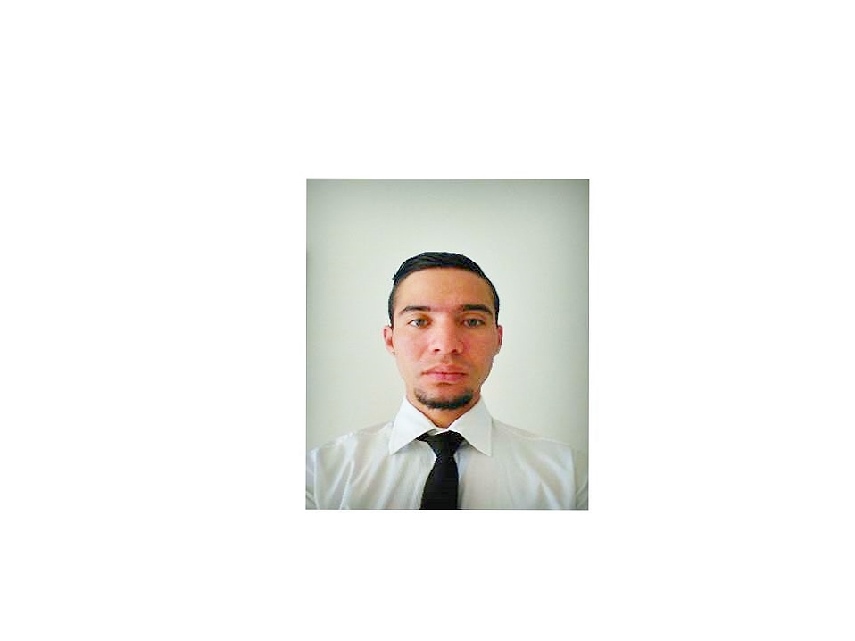
FRANCISCO ALEJANDRO PÉREZ TORRES
Email: perezfrancisco53@yahoo.com / phone: +971502919113 / Skype: chefperez23
OBJECTIVE
Highly enthusiastic and achievement oriented individual seeking for a position where I can apply my culinary knowledge and skills towards the growth of the company and, at the same time, acquire more experience to develop my career further.
SKILLS
- Culinary background: Able to cook any kind of Latin American and Mediterranean cuisine.
- Leadership: Able to manage big groups of people, set duties and make them work under pressure.
- Organization: Able to set all utensils, stuff, and equipments in my area before and after using.
- Costumer Service: Worried about keeping the standards of quality expected by the costumers.
- Motivation: Able to motive any teamwork in order to fulfill costumer’s experience.
- Problem solving: Able to solve any kind of problems regarding the kitchen.
EXPERIENCE
• June 2015 – August 2015. Cooking Teacher. “Timber Lake West Camp” summer camp
In charge of teaching to the kids all different techniques regarding culinary arts.
Jennifer DeSpagna (jennifer@camptlc.com)
United States of America
• August 2014- September 2014. Executive Chef. “Children Station” summer camp
In charge of all kitchen operation regarding lunch for the kids.
Daniela Escobar (estaciondechamos@hotmail.com)
Venezuela.
• December 2013- May 2014. Commis 1 “Caffé Hillel Sports & Deli”
In charge of preparing lunch for the costumers, with high demands of meals.
Messod Gabizon (+58 212-9351717)
Venezuela
• August 2013- September 2013. Executive Chef. “Children Station” summer camp
In charge of all kitchen operation regarding lunch for the kids.
Daniela Escobar (estaciondechamos@hotmail.com)
Venezuela.
• August 2012- September 2012. Executive Chef. “Children Station” summer camp.
In charge of all kitchen operation regarding lunch for the kids.
Daniela Escobar (estaciondechamos@hotmail.com)
Venezuela.
• June 2011- August 2011. Sous Chef. Plaza’s Supermarket Serving Food Restaurant.
In charge of preparing lunch for the costumers, with high demands on meals.
Venezuela.
• June-2008 / August-2008. Kitchen Staff, YMCA New York (Timber Ridge Camps)
Timber Ridge Camps is a summer camp held annually in the United States in West Virginia for children. Among my responsibilities was to ensure the maintenance of the kitchen and utensils, monitor the kitchen staff work, check the food with the chef, organizing menus and assist the chef in preparing each plate as quick as possible and finally distributing the food on each station.
United States of America. www.trcamps.com
EDUCATION
• Bachelor in Modern Languages Translation, Central University of Venezuela (CUV), (2006-2013)
• Diploma in Gastronomy at “Our Daily Bread Education Cooking Center” (2010-2012)
OTHER SKILLS
Languages
• Spanish, written and oral (Native)
• English, written and oral (advanced)
• Italian, written and oral (advanced)
Office Package
• Windows/IOS.: advanced-level (XP,Vista, Windows 7, Windows 8)
• Office suites: advanced (Word 2007-2010, PowerPoint 2007-2010), advanced (Excel 2007-2010)

