CV: Flemming Dørken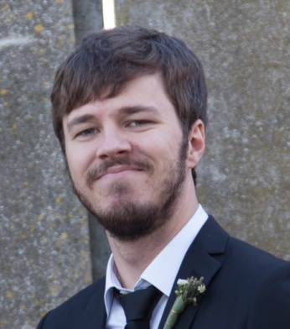

Personal
- Age: 26 (09/10-1987)
- Nationality: Danish
- Living in Aarhus, Denmark
- Married, 2013
- E-mail: flemming@doerken.dk or flemmingdoerken@gmail.com
- Phone: +45 2083 4300
- Skype: Flemmingdoerken
- Paypal/Skrill: mangofan@gmail.com

Education
- High school, Skive Denmark, 2004-2006

- BA in Linguistics and Anthropology, Aarhus University, 2010-2014
Selected results, based on the ECTS Grading Scale:
- Text Analysis: B
- Litterary and Cultural Translation: B
- Language, Culture and Society: B
- Danish and the Languages of the World: B

Freelance Translation, Proofreading, Language Assessment or Transcription Work
- Bigbuy.eu, 2014--
- Regular translator, product descriptions

- Translationcloud.com, 2014--
- Regular translator, app translation
    - Barry Steakfries
    - XnRetro

- Gengo.com, 2013--
- 500+ translation jobs. Clients include:
    - Clearsmoke Electronic Cigarettes
    - Mobil 1
    - MacReviver
    - JjsHouse
    - Battle of Tiles Ex
    - AVG Internet Security
    - Manchester United Football Club official facebook page
    - TimeSheet (iPhone app)
    - Glympse (mobile app)
    - Bible.is (mobile app)
    - Piano Companion (mobile app)
    - 4 Pictures, 1 Word (mobile app)
    - Curling Cuties (mobile app)
    - Netflix.com (subtitles translation)

- Motaword.com
- Legal text

- Open Doors Denmark (Åbne Døre), 2007-2012
- News articles

- Active Gaming Media
- Manual for medical device (translation and revision)
- Divekick (product description)
- Google Adwords

- Verbatim Globalisation Solutions
- Subtitles for Robin Hood & His Merry Mouse (Animated feature film, 58 mins)
- Subtitles for The Asphalt Jungle (Feature film, 112 mins)
- Subtitles for Pretty Little Liars (TV-series, 45 mins/episode)
- Subtitles for The Mentalist (TV-series, 45 mins/episode)

- View Globally
- Instructions manual for electrical company

- ComTranslations
- Subtitles for movie trailers

- Clickworker.com
- Proofreading jobs

- BD Swiss (BDSwiss.com)
- Proofreading of website

- Verkstaden (Verkstaden.dk)
- Linguistic review of website

- Gibson Research Consultancy
- Language assessment of medical research questionnaire

- Somya Translation Pvt. Ltd.
- Proofreading legal text

- Clixon
- App translation

- Jourist (Jourist.info)
- IPA transcription of Danish phrasebook
Language skills
- Au pair in New Jersey, USA, 2009-2010
- Fluent English as an everyday language

- Grammar courses at Linguistics, University of Aarhus, 2010-2012
- Danish Grammar
- Structure, Meaning and Use
- Morphology and Syntax
- Conversation Analysis

- Propedeutics at Classical Philology, University of Aarhus, 2012-2013
- Latin and Ancient Greek at a High School A-level

Other online work
- NoTreble.com
- Community manager, paid, 2009
- Twitter manager, paid, 2013
- Contributor, paid, 2009-2010, 2013
- Contributor, unpaid, 2009

- Betway.dk, 2013
- Software tester

- Thebrandchecker.com, 2014
- Brand checker

