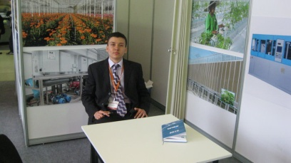

Farkhad Rakhmatov

Wageningen Gelderlands
farhad_ift@mail.ru

Summary

Sales Representative who consistently achieves customer retention goals through relationship building and advanced product knowledge.
Highly organized assistant of sales managers with 2,5 years in inside and outside sales. Innovative and attentive to details with outstanding follow-through
Talented sales professional who effectively multi-tasks and balances customer needs with company demands.
Efficiently builds loyalty and long-term relationships with customers, while consistently reaching sales targets.

Highlights

- Friendly and cheerful
- English speaking
- Turkish speaking
- Goal-oriented

- Approachable
- Russian speaking
- Self-sufficient
- Detail-oriented

Accomplishments
Conducted sales of Agricultural equipment from EU to Russia and Central Asian countries.
Gained sufficient experience in translation of English and Turkish technical documentation related to Agribusiness and Food Industry.

Experience
Assistant of sales manager
January 2010 to August 2012
IFT Project Development – Almaty, Kazakhstan
Answered customers’ questions regarding products, prices and availability.
Attended trade shows and sales conferences.
Collaborated with colleagues to exchange selling strategies and marketing information.
Responded to all customer inquiries in a timely manner.
Organized joint sale calls with current customers and outside vendors.
Shared product knowledge with customers while making personal recommendations.

Education
Bachelor: International Agribusiness and Trade
Van Hall Larenstein – Wageningen, Gelderlands, Netherlands.
Group works and workshops in Marketing, Finance and Trade in Agribusiness.

