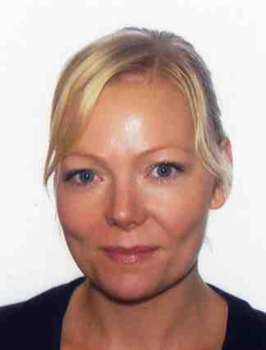
Eva Karlsson
Journalist/Copywriter/Social Media Strategist/ Translator

Personal Details
Address: Ottervattnet 231, 916 93 Bjurholm, Spain
Home Tel: +46 70 2352286
Email: schveky@hotmail.com

Introduction
At the moment I´m running a personal blog about Mallorca in Swedish called Mallorcabloggen. I’m also starting up my own business informationskonsulten.se (wordpress site). I translate texts, which I have been doing for the last 5 years. Language combinations: English - Swedish, English - Spanish, Swedish - Spanish and Spanish - Swedish. Translations for Speaklike.com among others.

Career History

06/2013 - present Social Media Strategist and copywriter at Informationskonsulten.se
CEO and owner of the company Informationskonsulten.se. Planning and social media strategies for companies. Copywriting and translations.

09/2010 -01/2013 Information Manager and Community Manager at Zleepinghotels.com (Mallorca)
Internal and external communication. Responsible for the information submitted in 6 languages (English, Swedish, Spanish, Finnish, Danish and Norwegian). Social Media strategist managing social networks like Twitter and Facebook, Hootsuite, Tumblr, YouTube, LinkedIn... PR, press releases, articles for magazines, etc..

06/2009 – 12/2009 Clinical Assistant. Älvgarden (Sweden)

Nursing home. The basic function was to take care of the elderly and help them with their daily grooming. The work also involved social functions and preparation of meals and snacks.

02/2008- 12/2008 Sales Excecutive Majorcahouses.com

Selling properties in Mallorca.

11/2006 - 02/2008 Sales Executive. Taylor Woodrow Spain (now Taylor Wimpie)
Selling properties in Malaga and later on, in Mallorca.

03/2006 – 11/2006 Promotor / vendor Loreal. Luxuries products at Malaga Airport
Sales Promoter

09/2005- 03/2006.Sales Executive. Finca Doña Maria.

Selling properties in Southern Spain. Benalmádena area.

03/2005 - 09/2005 Bank Cashier Solbank Nueva Andalucía (Marbella)

Bank Cashier

12/2004 – 03/2005 Sales Executive Calahonda Estates

Selling properties in Southern Spain. Fuengirola, Calahonda and Marbella areas.

05/2004 – 10/2004 Loreal Promoter, luxury products. Malaga Airport.

Sales functions, preparing reports, orders, product placement as the company's marketing, selling perfumes, creams and makeup brands of GDP (Lancome, HR, Biotherm, Armani, Cacharel, Ralph Lauren, etc..) promotions, etc.

03/2003- 09/2006 Promoter. Clave.

El libretón de BBVA.Centro comercial la Rosaleda. Málaga.
Dunhill. Málaga Airport. Azafata de promociones. Palacio de Congresos. Torremolinos. Exhibition: ”España en los años 50”. Museo Municipal. Málaga. Marlboro, Málaga Airport. Lucky Strike Málaga Airport. Azafata. Exhibition ”Pintores malagueños”. Museo Municipal. Málaga.

Education

2000-2004 BA/Hons in Journalism. Second class,first division degree.EADE, Málaga.

Courses

01/2013 - 05/2013 Social Media Strategist

03/2012 Community Manager 20 hours

09/2011 - 01/2012 Chinese A

10/2009 - 05/2010 Spanish B1, Umeå Universitet. Degree: VG (4/5).

01/2009 - 05/2009 Airport Operations, 290 hours, Marratxi, Mallorca

10/2007 - 11/2007 Marketing, 50 hours, IVAFE, Valencia

10/2007 - 11/2007 Foreign Trade, 40 hours, IVAFE, Valencia

01/2000 - 05/2000 Spanish A1, Umeå Universitet. Degree: VG (4/5)

09/1998- 05/1999 Spanish, Malaga University for Foreigners.

Other experiences:

Julio- Septiembre 2002 Work practice. Onda Cero International Marbella.

Blogs:

My blog about Mallorca: Mallorcabloggen.se

My blog about Social Media: Por los ojos de una Sueca

Translations:

CAT Tools: Trados, Inglés-Spanish Interpreter Pro

Books, manuals, letters, general documents, legal texts, etc.

Level test: If you want to see how I translate, send me a sample A4 text and I will translate it for free.

