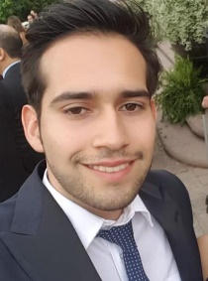
Contact
Phone: 664-696-0621
Email: thefernandeztranslations@gmail.com
Address: Col. Guadalupe Victoria, Calle Ing. Juan Ojeda Robles #14701 22426
LinkedIn: Esteban José Fernandez Cisneros
Languages
° Spanish – Native
° English – C1
° Japanese – N4

Schooling
Degree in Translation – Universidad Autónoma de Baja California
References
° Nohemy Quintana – ARRA Capital
553-562-3300
° Carolina Muller – Rockstar Staffing
777-328-3249
ESTEBAN JOSÉ FERNANDEZ CISNEROS
Translator & Interpreter
Experience
° Freelance translator and interpreter – Currently
Experience with technical, legal, medical, advertising and Enterprise documents. Previously collaborated with companies of different fields translating contracts, instructions, flyers, advertising, etc. Interpreting for hospitals and companies.
° Rockstar Staffing – Administrative assisstant and customer service representative – 05/29/2019 to 10/17/2019
Welcoming visits from both customers and contributors, emailing, answering calls, linking calls to carry out the procedure of recruitment or distribution to different areas, clarifying doubts and follow-up during the customer entry and incorporation into the company.
Specialized treatment with clients, email management, administration of the company’s official website in social media.
Translation of advertisements, declaratory documents, corporate texts, contracts, commercial proposals, proofreading.
° Business Capital – Freelance translator and advertising designer – 06/15/2018 to 04/21/2019
Translation of the company’s business texts and documents.
Proofreading.
Creation of content, flyers and operational advertising to attract talent through social media.
Abilities
° Technical, legal, journalistic, medical and literal translations
° Simultaneous and consecutive interpretation.
° Proofreading.
° Video and audio transcription.
° Memorization of company’s data.
° Management, upgrading and administration of social media.
° Office.
° Adobe Photoshop.
° Digital content creation.
° Traditional illustration.

