CURRICULUM VITAE

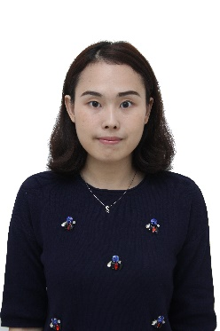
Personal Details

Name : Elvia Cynthia Dewi
Sex : Female
Place, Date of Birth : Jakarta, 26 July 1990
Nationality : Indonesia
Marital Status : Single
Health : Perfect
Religion : Buddha
Address : Jl Musyawarah no 8 RT006/013, Kebon Jeruk
Phone : -
Mobile : 081297959076
E-mail : elviacynthiadewi@hotmail.com

Educational Background

1996-2002 Elementary School, SD Tarakanita-Indonesia
2002-2005 Junior High School, SMP Tarakanita-Indonesia
2005-2008 Senior High School, SMA Tarakanita-Indonesia
2008-2009 Chinese Language, Guangxi Medical University-China
2009-2013 Bachelor of Advertising, Guangxi University-China
2013-2014 Master of Tourism (Not Finished)

Course & Education
2000-2007 English Language Course at Eloquence, Tangerang

Qualifications
Computer literate (MS Word, MS Excel, MS Power Point)
Internet literate
English proficient (both written and oral)
Chinese proficient (both written and oral)
Working in individual or team

Working Experience
2009-2013 Translator at GuangXi-China Expo
2014 Private Educational English/Chinese Course
2016-Now Consultant at Everyone Happy Entertainment

