Curriculum Vitae
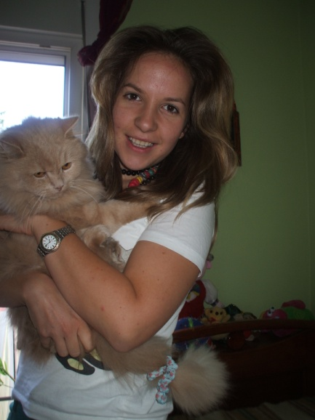
CONTACT INFORMATION
Name : Dunja Spiler
Address: ul. Nikole Tesle 8/9 11080 Belgrade
Country: Serbia
Telephone : +381112607569
Cell Phone : +381641314824
Email: dunjaspiler@ymail.com

PERSONAL INFORMATION
Date of Birth : 21.10.1985
Place of Birth: Belgrade
Citizenship: serbian
Gender: female

Additional Personal Information:
Marital Status: single
EMPLOYMENT HISTORY
Work History
In the past few years I have been working as translator for german and english language. I usually translate tourist arrangements from english in german, english in serbian and serbian in english and german. Serbian ist my native language since I was born and grew up in Belgrade, the capital city of Serbia.
EDUCATION
High School : Philological High School ( department for german language, english was my second language)
University: Philological University of Belgrade (department for german language and literature, italian was my second language) (from 2004 until 2010)
LANGUAGES
Serbian, English, German, Italian.
INTERESTS
I like riding bicycle, learning new languages, hanging out with my friends and family.

