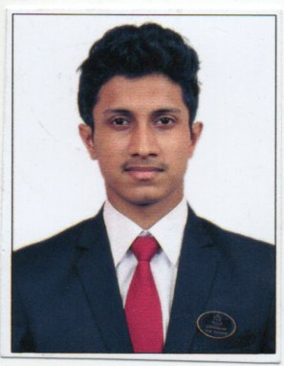
Curriculum Vitae

Name : DIPANKAR MAITY
Age : 20
Date of birth : 27/101997
Permanent Address : 62, Dr, MN Saha Road,
Dum Dum, Kolkata-74
Phone / Mobile : 9051483784
E-mail Id : dipankarmaity432@gmail.com

Goals / Objective: To achieve the top most position in my
Respected department by my
Skill and knowledge.

Educational Qualifications:

Qualification | Specialisation or Subjects | School / College / University / Institute & Board | Year of Passing | Total marks % / CGPA
Graduation:  1st Semester  2nd Semester  3rd Semester(It)  4th Semester  5th Semester | Food Production  F&B  Housekeeping  Front Office  Food science  Communication  Accounts  Facility Management | Institute of Hotel  Management, Catering  Technology and Applied  Nutrition, Kolkata | 2015 pursuing | 60.4%  60%  62.5%  75.80%  74.60%
HSC / 12th / ___ | Bengali  English  Chemistry  Mathematics  Physics  Biology | Dum Dum  Kishore Bharati High School | 2015 | 81%
SSC / 10th / ___ | Bengali  English  Mathematics  Physical science  Life science  History  Geography | Dum Dum  Kishore Bharati High School | 2013 | 79%

Industrial Experience:

No of Weeks / Months | Organisation | Job Responsibilities | Awards / Recognition
4 months | Novotel Kolkata  And Residences | Industrial Trainee in 4 core departments, as well as 2weeks in Finance Department | 100% Attendence

Hobbies / Interests:

● Football
● Music
● Photography

Languages known:

Sl. No. | Language | Read | Write | Speak
1. | English | Excellent | Excellent | Very Good
2. | Hindi | Very Good | Very Good | Excellent
3. | Bengali | Excellent | Excellent | Excellent

SIGNATURE
DATE:

