Dinsefa Hassen
English to Amharic Translator

Translator

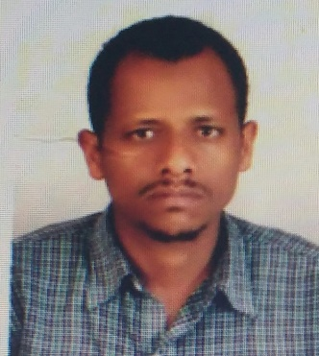 |  | Dr. Dinsefa Hassen  English Amharic

Resume
I am a native speaker of Amharic.
My minimum rate is 0.04 Euro per source word.
But I prefer to work at 0.05 Euro per source word.
I charge for my services at least 10 Euro per hour.
And my minimum charge per document is 10 Euro.
I can provide the following services: Translation, Proofreading, Subtitling, Voice-over, Teaching (Any Natural science Courses), Typing and Data Entry.
I can use the following tools: Application softwares,Ms-Word,Ms-Excel,Ms-Access,Power point,Adobe Phototshop.
I am best in the following fields: Accounting & Auditing, Advertising & Public Relations, Agriculture, Arts and Humanities, Cinema (Film, TV, Drama), Cosmetics / Beauty, Diplomas / Certificates / Etc , Education / Pedagogy, European Union, Finance / Economics, Food / Nutrition, Forestry / Wood / Timber, General, Geography, Geology, Globalization, Government / Politics, History, Human Resources, Insurance, Journalism, Law (Banking & Financial), Law (General), Law (Contracts), Law (Patents, Trademarks, Etc ), Law (Taxation / Customs), Linguistics, Literature / Poetry, Localization, Management, Media / Multimedia, Medicine (General), Medicine (Cardiology), Medicine (Dentistry), Medicine (Health Care), Medicine (Instruments), Medicine (Pharmaceuticals), Military, Music, Philosophy, Photography / Graphic Arts, Psychology, Real Estate, Religion, Shipping & Maritime, Slang, Social Science, Sports / Recreation / Fitness, Transportation / Shipping, Travel & Tourism, Zoology.
I am a sworn translator.
I am available for work Full week, Monday through saturday.
I can provide you with references on request.
The following keywords are related to my services: Honesty,Quality and Promptness
If you would like your English documents to be translated in to these languages in an online/offline basis, please get me in touch.
I am sure you get satisfied with the quality translation service I render.
Honesty, Quality and Promptness are my virtues
Regards
Dinsefa Jemal
Telephone +251937875237 Email:- (mohazeba@gmail.com)
Contact details
I live in Addis Ababa
30303
+251937875237

