RESUME

DEBANGA PALLAV SAIKIA 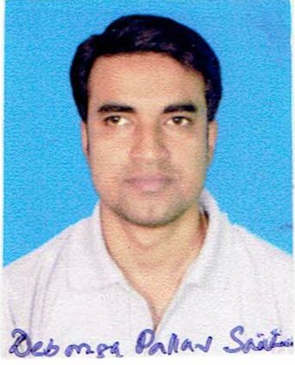

CONTACT NO: +91 8860515949

E-MAIL: debangapallav4u@gmail.com

PRESENT ADDRESS:
HOUSE NO. 18 (B)
Lakhimi Nagar Byelane 1
Near Laxmi Mandir
Beltola
Guwahati
Assam 781028

PERMANENT ADDRESS:
C/O: Late Kiran Saikia
VIll: Majjajori
P.O.: Maj Gaon
DIST.: Nagaon
Assam
782142

DATE OF BIRTH: November 30, 1981.

EDUCATIONAL QUALIFICATION
1. HSLC in 1997 from Jajari Higher Secondary School, Nagaon, Assam, with II division.
2. HSC (Arts) in 1999 from Kujidah Higher Secondary School, Nagaon, Assam, with I division and letter
marks in Education and Assamese.
3. B.A. (English Hons) in 2002 from Cotton College, Guwahati, Assam in 2002 with II class.
4. M.A. (English) from Guwahati University, Assam in 2005 with II class.

EXPERIENCE IN LITERATURE
- Short story writer in Assamese. Stories have been published in many prestigious magazines of the Assamese language. Two published books, one being a short story collection, entitled Noir Dore (Like the river), now running third edition, published by Sanjivan Prakashan, Guwahati.
- Essay and article writer in Assamese, published in magazines and newspaper.
- Freelance translator.

OTHER ACTIVITIES

- Anchoring in Assamese.
- Freelance vocalist in Assamese, latest number released “Roi Jaa Boi Thoka noi” available in all leading musical platforms like Gaana, Spotify, Saavn, etc.

Competencies

- Fast learner. Adapt well to changes and pressures in work place.
- Work effectively with diverse group of people.
- Friendly with an upbeat attitude.
- Ambitious, hardworking and committed to excellence.
- Charismatic with positive attitude.

DECLARATION:
I hereby declare that the above informations are true to the best of my knowledge.

