Petrus Codin Adrian 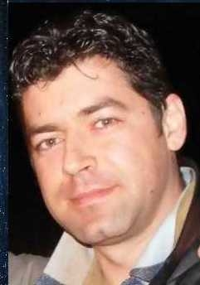
(M, 41, Satu Mare, single)
Mobil: +40-749-518-438
Email: codin13@gmail.com
codin_adrian_petrus@yahoo.com
-------------------------------------------
Objectiv
Areas: trade, advertising, publishing
a job with the possibility of professional and material achievement in Satu Mare area
Willing to travel: yes
Experience
Insurance agent (Part time)
Period: 2011-08 to present
Firm, location: ASICONS BROKER ASIGURARI, Satu Mare
Occupation / field: Insurance
Insurance contracts, customer contacts management, storage portfolio
-----------------------------------------
Customer service manager (Full time)
Period: 2007-04 <> 2011-04
Firm, location: Allianz Tiriac Asigurari, Satu Mare
Occupation / field: Insurance
Insurance contracts, training for agents, clients and portfolio management policies,
Life/non-life insurances sales strategy and planning
---------------------------------------
Trade worker, agent
Period: 2006-01 <> 2006-06
Firm, location: Satu Mare, RPD Company,
Ocupation / field: acquisitions
supply units that sells office stationery products
Responsibilities:
Customer contacts, taking orders, contacts maintenance
----------------------------------
Insurance agent
Period: 2004-08 <> 2006-01
Firm, location: Satu Mare, Asigurarea Romas CECCAR
Ocupation / field: Insurances
Insurance contracts, portofolio management, presenting the benefits and advantages of the products
Proofreader
Period: 2001-08 <> 2003-05
Firm, location: Satu Mare, Gazeta de Nord-Vest Newspapper, Viata Newspapper
Ocupation / field
Local newspappers
Proofreading, pages and texts editing
----------------------------------------
Seller
Period: 1994-01 <> 1999-09
Firm, location: Antique Book Store AF, Constanta
Ocupation / field: Sales
Purchase of books, assessment, sales, customer contacts management
Studies
College / Graduated studies
Babes Bolyai University (2003 - 2005), Satu Mare
Profile: Public affairs
---------------------------------------
Popular University Satu Mare (1991 - 1992), Satu Mare
Profile: Comerce
---------------------------------------
School /High School/ Vocational school
Teoretic Ioan Slavici High School(1987 - 1991), Satu Mare
Diploma, qualification certificate
-----------------------------------------
Management experience: Yes
Driver licence: No
Good communication skills, sense of responsibility, strong character, overtime availability, malleability, good psychological knowledge, kindness
Languages
English – advanced
Greek - good
Hobby
Business , Commerce, Tourism , Dating , Community, Literature, Sports, Entertainment, Music, Computers / Internet

