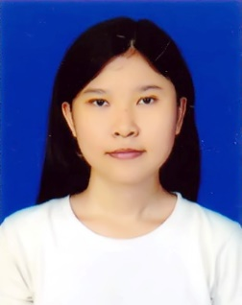

**PERSONAL DETAILS**

* Birth March 8, 1999
* Address No.30, Pathein Nyunt 6th Street, Myittar Nyunt Township, Yangon
* Phone +959778928583
* Mail Address chuethinzar827@gmail.com
* N.R.C Number 7/PAMANA(N)198356
* Sex Female
* Nationality/Religion Burmese/ Buddhist

**Chue Thinzar Win**

Curriculum Vitae

**EDUCATION**

* 2014-2015 (Pass Matriculation)
* International Relations, Third Year ( Dagon Universtiy, Yangon)

**Skills**

* English ( Fair )
* Japanese (greeting)

ဲဲ

ဲဲ

**Courses and Training**

* English Language Advanced Course ( Researchers English Language Class )
* Certificate of Business Management (National Management College)
* Microsoft office 2010 Course (MCC Ltd.,)
* Barcamp event organizing Training, Dagon University, 2017

**Volunteering and Organizing**

* Dagon University Barcamp 2017 event’s Organizer (worked as an Admin Team organizer_ managed the needs in Dagon University’s convocation for Barcamp’s day and worked as a manager in room services and reception in Barcamp’s day.)
* Pix’arts first event of volunteer, Institute Francais de Birmanie, Yangon(worked as an volunteer in where microfolie shows about virtual images and videos, helped VIPs, school children and visitors how to use and watch the tablets showing about France’s culture and others.)
* Yangon CSOs Forum ( worked as an volunteer in the second time of Forum)
* White Moon Light Philanthropic group (performing leader of the group, is a kind of charity and a labour of love)
* Teach for ASEAN (working as an assistant teacher in there)
* U-Report Myanmar, Yangon (One of the selected member of the U-Report Content Group and working as an active member in there)