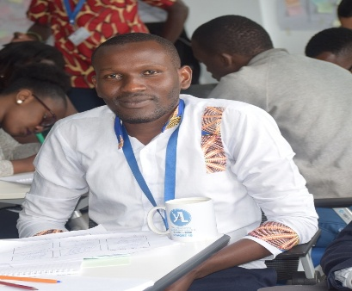

**CHRISTOPHER MWAZIGHE PHILLIP**

Translator

**Profile**

I am a competent translator with diverse skills in translating in different languages. I translate for websites, blogs, research and technical fields. I possess skills in general translation, transcription, content writing, copy-writing, editing & proofreading, web research and technical writing. I work on tasks based on the client’s instructions.

I have been a reliable translator for the past 7 years. Therefore, I have experience in translation using appropriate keywords in different contexts such as organizations, agencies, media firms and institutions. My experience and expertise has been a great advantage to these firms since they have highly leveraged my skills and knowledge.

My greatest interest is to boost the reputation of companies, clients and agencies. I follow instructions and directions to meet the client’s requirement.

**Work Experience**

UNODC – Youth conferences

Translator 2018-2020

Translation and interpretation from source language to English and Swahili. Involved in converting documents and articles from source language to English and Swahili and ensuring that the converted articles relay the intended message as clearly as possible.

***Duties:***

* Researching legal and technical phraseology to ensure correct translation
* Liaising with clients to discuss unclear points
* Supporting the translation team with other projects when necessary
* Excellent English and Swahili speaking and writing skills

**Key Skills and Competencies**

* Familiar with translation software
* Able to speak fluent English and Swahili
* Able to work on tight deadlines
* Highly skilled on Word, Excel and translation platforms
* Willing to travel and able to work under pressure
* Able to prioritize work

**Academic Qualifications**

Diploma in Linguistics (Translation Media) - Technical University of Mombasa 2015 – 2018

Writing and Translation, Data Management – Ajira Digital Kenya (2020 – 2021)

**References** – Available on request

**Areas of Expertise**

Translation, Transcription,

Copywriting, Content writing,

Technical writing, Proof reading, Interpreting, Data management,

Data entry, Research, Data mining,

Digital marketing

**Tools**

Ms. Word, Excel, CAT Tools, SAS,

I MISS SPSS, RAPID Miner, Adobe,

R Programming

**Personal Skills**

Problem solver, outcome

Oriented, flexible, critical

Thinker, self-disciplined

Good communication skills,

Well organized

**Personal Details**

Tsavo National Park Road,

P.O.Box 409 – 80300,

Voi – Kenya.

Mobile No. +254 (0) 713 316 149

Email: [christophermwazighe@gmail.com](mailto:christophermwazighe@gmail.com)

DOB. 06/10/1993

Nationality: Kenyan