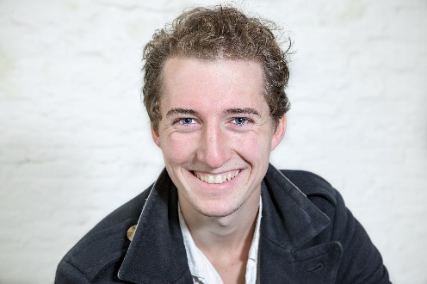
CHristopher
de Sadeleer
Avenue Massenet 9, Bruxelles, Belgique
+32486735264
Christopher.ds@hotmail.com

Professional skills

Translation, proofreading and interpretation skills in Norwegian, French and English languages
Theatre acting, acting for the screen and voice acting skills

Formation
Secundary diploma from the Scandinavian School of Brussels
Theatre Formation in Nordmøre Folkehøyskole, Norway
Studies in Dramatic arts in the Royal Conservatory of Brussels, still in course

Professional experience
Actor and voice actor for 16 Escalones Producciones, december 2020
Main actor in Catch 22, by Gaëtan Jossart, 2019

Languages
Native : French, Norwegian and English
Fluent : Spanish

