Catherine
KERR-PHILLIPS
2 Ayre View, Old Town
Hebden Bridge
West Yorkshire
HX7 8SX
petithoux@hotmail.com
01422 844311
Experience

2006-2010
(Jobs to fund my studies)

2002 - 2004
Seasonal work

2002 Summer season
Tourist guide

2000 – 2002
Reception / Secretary

Hobbies

DIPLOMAS
2006 - 2009

2001

SKILLS

Curriculum Vitae 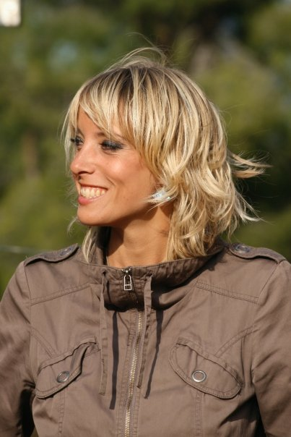

Qualifications and Experience

Translation and Interpreting
- Translating emails, documents, websites, proof reading articles and scripts in English, French and German, interpreting and customer service for various employers (please see below for references)
Nice (France), Bastia (Corsica), Würzburg, (Germany)

Bilingual receptionist
- Greeting and booking English clients, interpreting between clients and the hotel employees, and the local businesses, Mark Warner. Les 2 Alpes, (France) and Moriani Plage (Corsica).

Tourist guide, supervising sporting activities
- Greeting and accompanying foreign clients (mainly German, French and English) on various sporting activities (kayak, canyoning, horse riding, trekking) Patara Beach (Turkey).

Receptionist and Secretary
- Studio BAAD Architects (UK).

Ongoing Projects: translation, writing, painting, voice-overs, reporting, acting and modelling

- Learning prop building and classical painting techniques at « Le Trompe l’œil » Victorine Film Studios, Nice.
- Translation of architectural texts for the Comorian Heritage, UNESCO, and conference material for Prof Nicole Attia, University of Nice, France.
- Bilingual voice over for Sound System, Aix les Bains, France.
- Acting and modelling in Nice and Marseille, France.

Economics, Business, Law and Languages, University of Nice, France
- Double bachelors degree specialising in English, French and German

TEFL
- Three day intensive teaching course

Languages : IT Skills :

Fluent English Microsoft Word
Fluent French Internet
Good spoken and written German Powerpoint
Basic Italian
Basic Hindi

References

Mr. Andreas Fersch
Business owner, Germany
Andreas.fersch@seib-itc.de
0049 931 35503777

Mr. James Loftus
Architect
j.loftus@studio-utopia.com
07541 188584

Mr. Loic Berthezène : Production director.
Paris/ Marseille,France loberthezen@hotmail.com
0033 607063595

Mr. Jean-Paul FRANCESCONI :
Business owner, Corsica.
0033 610 821407

Mr. Jean-Marc Bobillon : University professor
jean-marc.bobillon@unice.fr

