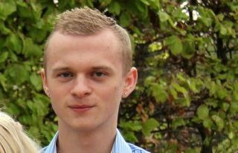
Brian Rosengren Petersen
Cusco, Peru
974372663, 940414064
mc-biver@hotmail.dk
Skills and Profile:
- Over 10 years of experience in customer service skills and over 4 years of managing
- Knowledge about Peruvian/Cusco culture and history
- Experience in the work of archaeology
- Trained in guiding and selling
- Computer skills in: word, excel, movie maker and e-mail
- Social work in Huyro, Peru with children (English teaching, entertaining)
- Danish: fluent, spoken and written (native language)
- English: fluent, spoken and written
- Spanish: fluent, spoken and written
- Holder of residence card of Peru and registered as a worker (Carné de Extranjería)
- High customer service (10 years of experience in selling and helping customers)
Work History:
- 6 and a half year in Netto, Supermarket (4 and a half year as a manager)
- Volunteered as an archaeologist through “Project Abroad” in the inca-project in Huyro, Peru (4 months)
- Experience in the reservation and selling area, marketing/promotion, translations and operating in several travel agencies in Cusco for 2 years
- Owner of the travel agency Cusco Unique Experience for more than 5 years
- Worked as a translator and translated several texts from foreign companies from English to Danish
Education History:
- Haslev Gymnasium (college), STX, language-/society direction (3 years)
- Spanish course in Costa Rica (2 months)
- Guideschool in Spain (5 weeks)

