Resume
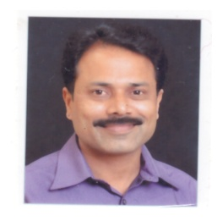
Personal Information

Name : Bhaskar Amrut Sonawane

Date of Birth : 05 January 1972

Cast : Buddhist (SC)

Nationality : Indian

Ethnicity : Maharashtrian

Profession : Proofreader (Editing), Freelancer in Translation

Permanent Address : Shivankur Hos. So., Flat No. 10, 2nd flr.,
Gurudwara, Walhekarwadi, Pune : 411 033

Cell No : 9762448257

E-Mail Id : sonawanebhaskar7@gmail.com

Languages : Marathi, Hindi and English

Language I can Translate : Hindi to Marathi, Marathi to Hindi, English to Marathi
Rate per word : .70 Rs. Per word and variable
(Depends on Project)

Marital Status : Married

Education Qualification : M.A. B.Ed, Diploma in Mass Communication Journalism

Education | University/Board | Year of Passing | Percentage
B. A. | UMV, Jalgaon | 1998 | 63.5
M. A. | UMV, Jalgaon | 2001 | 54.5
B. Ed. | UMV, Jalgaon | 2004 | 64.5
MCJ | YCM University, Nashik | 2014 | 60.5

Experience Details : Worked daily News papers

Personal Information

- Freelanceing in Translation and Proofreading since 2018
- Prabhat News Paper – 2003 to 2005
- Lokmat News Paper – 2005 to 2014
- Sakal News Paper – 2014 to 2020
Dail output (inwords) : 2000

Thanks,

Bhaskar Sonawane
Pune, Maharashtra

