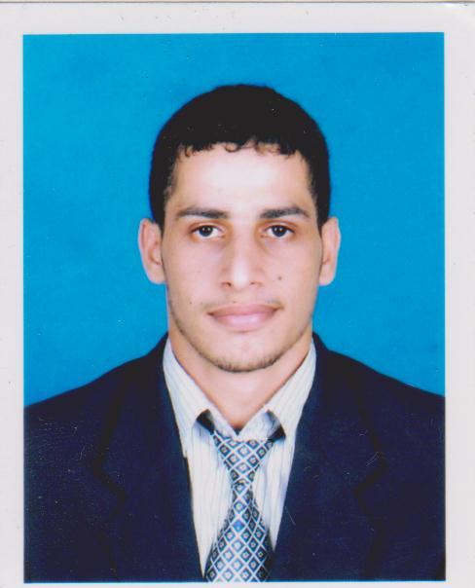
Belal Mohammed Abdullah Al-hamzi

Contact Info
Address : NO 8 JLN 2/3, Melewar 2, Parit Raja, Batu Pahat, Johor, 86400
Mobile No. : 0060-172558534
Email : alhamzib@gmail.com

Personal Particulars
Age : 27 years old
Date of Birth : 1st Jan 1987
Nationality : Yemen
Gender : Male
Marital Status : Single
Passport Number : 04160265
Permanent Residence : Almahwit , Yemen
Educational Background
Bachelor's Degree
Field of Study : Engineering
Major : Bachelor Degree in Electrical Engineering
Field of Study : Electrical
Institute/University : Universiti Selangor
2008-2012
CGPA : 3.65

Master’s Degree
Field of Study : Engineering
Major : Master’s Degree in Electrical Engineering
Field of Study : Power
Institute/University : Universiti Tun Hussein Onn
2013-2014
CGPA : 3.79

Technical Skills
Skill | Years | Proficiency
Matlab | 5 | Intermediate
Circuit Designing (Multisim Software) | 3 | Intermediate
Circuit programming (VHDL programming language ) | <1 | Beginner
C, C++ programming | 1 | Beginner
Circuit Designing (Pspice Software) | 2 | Intermediate
Tina | 1 | Intermediate
PLC | 1 | Beginner
AutoCAD | 1 | Intermediate
Protues | 2 | Intermediate
Microsoft office
Excel
Power Point
Ability to work with team
Ability to learn new technology
Languages
Language | Spoken | Written
English | 8 | 8
Arabic 9 9
Malay 3 3
Experience
- 4 months working in Asia M&E engineering Company “Operation Department”.
- 2 months school teacher
Additional Info
Personal characteristics: Punctual, independent, positive attitude, highly motivated with a desire for success, Vollyball team player, optimistic, willing to learn, problem-solver and able to work with minimum supervision, Main member of International Student Service (ISS) for 1year, joining 4 orientations activities during study.
Interest
- Reading
- Technology Adaptive
- Technology Enhancement
- Project Management
Miscellaneous
Willing to travel : yes
Willing to relocate : yes
Possess Own Transport : No
References
- M.K.A Ahmed Khan
Tel / 012-2305451
Email / khanbai@hotmail.com
(Senior lecturer in University Selangor)

- Dr. Tarek Messikh
Tel / 017-2923707
(Lecture in University Selangor)
- Dr. Kok Boon Ching
Tel / 0126107918
Email / bckok@uthm.edu.my
(Lecture, Supervisor at University Tun Hussein Onn)

