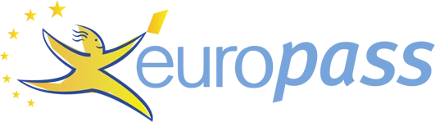

PERSONAL INFORMATION Aytan Mammadova
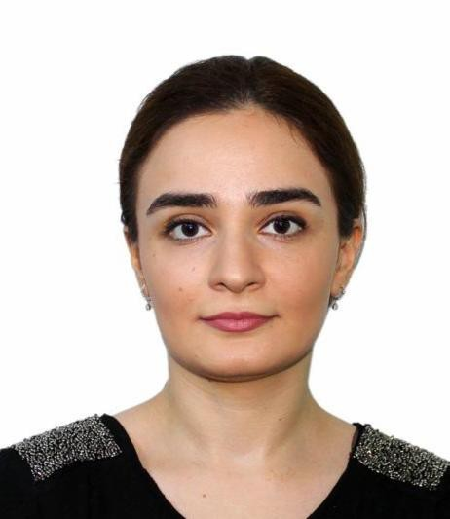
72 Anvar Gasimzadeh Street, AZ1007 Baku (Azerbaijan) +994504582773
aytan_t@yahoo.com

WORK EXPERIENCE

02/04/2019–09/03/2022 Senior Advisor
Ministry of Energy of the Republic of Azerbaijan, International Cooperation Department, Baku (Azerbaijan)
- Writing official letters
- Translating documents
- Preparing reports and information briefs
- Participating in official meetings

29/03/2018–02/04/2019 Advisor
Ministry of Energy of the Republic of Azerbaijan, International Cooperation Department, Baku (Azerbaijan)
- Writing official letters
- Translating documents
- Preparing reports and information briefs
- Participating in official meetings

17/07/2017–13/02/2018 Social Department Specialist
Javan Youth Movement – Youth organization, Baku (Azerbaijan)
- Researched social issues
- Translated documents
- Organized events

06/2016–07/2016 Intern
Ministry of Foreign Affairs of the Republic of Azerbaijan, European Department I, Baku (Azerbaijan)
- Gained practical knowledge about the organization and documentation procedures
- Translated official documents
- Archived official folders

05/2014–06/2014 Intern
Ministry of Foreign Affairs of the Republic of Azerbaijan, Department of Economic Cooperation and Development, Baku (Azerbaijan)
- Translated official documents
- Archived official folders related to international and regional organizations

EDUCATION AND TRAINING

15/09/2015–26/06/2017 Master of Arts in Diplomacy and International Affairs
ADA University, Baku (Azerbaijan)
- Geopolitics of Energy
- Theories of International Relations
- Advanced Research Methods
- Macroeconomic Analysis
- International Political Economy

15/09/2010–30/06/2014 Bachelor of Arts in American studies
Azerbaijan University of Languages, Baku (Azerbaijan)
- History of international Relation
- Business communication
- International Security
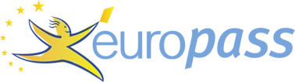

PERSONAL SKILLS

Mother tongue(s) Azerbaijani

Other language(s)
UNDERSTANDING |  | SPEAKING |  | WRITING
Listening | Reading | Spoken interaction | Spoken production

English C2 C2 C2 C2 C2
 | Certificate of IELTS Band score 7.5; British Council, Baku, Azerbaijan (2014)
French | A2 | A2 | A2 | A2 | A2
Spanish | A2 | A2 | A2 | A2 | A2
Russian | B2 | B2 | A2 | A2 | A2
Levels: A1 and A2: Basic user - B1 and B2: Independent user - C1 and C2: Proficient user Common European Framework of Reference for Languages

Digital skills SELF-ASSESSMENT

Information processing | Communication | Content creation | Safety | Problem solving
Independent user | Independent user | Independent user | Independent user | Independent user
Digital skills - Self-assessment grid
Certificate of Computer training course; CELT, Baku, Azerbaijan (2010)

