Asmaa Gamal  16th march 2000, Egy | Address : 18 khalil mutran st  Saba basha,Alexandria,Egy  Telephone: +2035846124  Mobile: +2001114594605  E-mail: Somsom_2000@yahoo.com
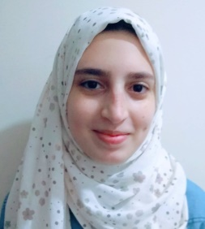
English and Arabic Instructor and translator –Applied languages student –English section with 1-year-experience in translating from English to Arabic.
EMPLOYMENT DETAILS
Future Institution  Job Title : English/Arabic translator | 1st March 2017 to 19th April 2018
- Overall responsibility to provide customers with the most satisfying result.
- Organized strategy to fulfill my mission on the convenient time.
ACADEMIC STUDIES
1-Arabic : B+ 5- Translation: B+
2-English : B
3-English-speaking civilizations B
4-Linguistics: B
OTHER INFORMATION
Keen on learning foreign languages and sharing knowledge with others. Reading is my means to fill my spare time.

