ASHIKUR RAHMAN
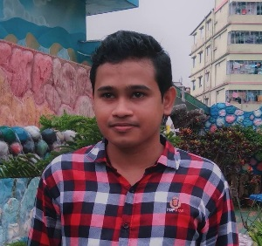 | Address: Sadar, Mymensingh, Bangladesh-2201  Phone: +8801553399790  Email: ashikura363@gmail.com  Website: https://www.facebook.com/ashikur60  Twitter: https://twitter.com/ashikur60  Skype: live:.cid.b18b7d501eecd94d

Objective
A proven multilingual expert with exceptional proficiency in English, and Bangla including the ability to translate from and to any of the language, as well as to use MS Office tools.

Education

National University
Bachelor of Business Administration-2015
Subject: Marketing

experience

Lecturer | Modern Technology College, Dhaka, Bangladesh
Subject: English
from 2017 – Running

Writer | Galaxy publications, Dhaka, Bangladesh
Subject: Bangla and English
From 2010 to 2016

Skills & Abilities
- Excellent content writing skills
- Well-developed translation skills
- Strong sense of urgency and self-confidence
- Proficient with Microsoft office tools

