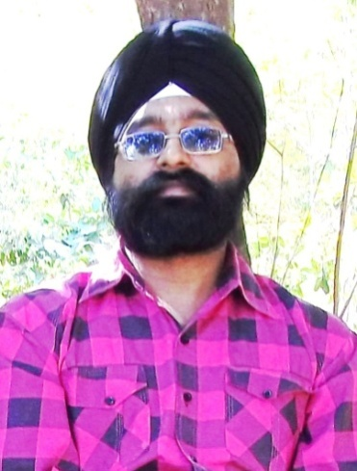

Arvinder Singh
(Freelance Punjabi Translator)
+91-9501320772 (India)
arvinderamritsar76@gmail.com

“People who love their Mother Language never fail in life”

- Working Area : Translation, proofreading

- Attitude : Reliable, Flexible, Expert, Full Night-Time, Client-Oriented,
Service-Minded, Constant availability

- Mother Tongue : Punjabi

- Source languages : English, Hindi, Punjabi

- Target languages : Punjabi, English

- Capacity : 2500 Words / Day For Translation, 6,000 Words / Day For Proofreading

- Rates : Per Word as per Project depth and Client Requirement

- Software : Microsoft Word

- Experience :
        - In translation and proof-reading (review) – 8 years
        - 15 Years working includes
        - Aviation Department
        - Computer Maintenance
        - Networking Department
        - Software/Web Development (Visual Basic -6 PHP MySql Ajax Scripting etc)

- Translation Works :
        - GENERAL (Education, Websites, Certificates, Correspondence, Tenders)
        - BUSINESS (Tourism, Accounting, Banking, Financial, Logistics, Shipping,
Warehousing, Catering and Trade, Insurance)
        - TECHNICAL (IT, Hardware and Software, Machinery, Electronics)
        - LEGAL (Contracts, Official Documents)
        - MEDICAL (General Medicals)

- Education :
        - BBA(Comp Appl), Dip. Computer Application
        - Dip. Telecommunication & Electronics
        - Advance Courses in AVIONICS Systems
        - Certification in Computer Network Security
        - Advance Course in Visual Basic 6 Programming

- Tech Experience :
        - Navigation System Maintenance, Test Benches Work, Repair ,
        - Modification in Avionics Systems
        - Computer Networking, Hardware Repair

