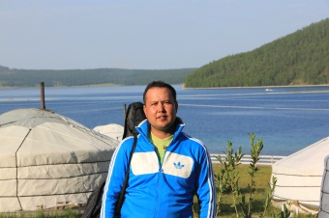
Artur DORZHIEV (born in December,18 1979)
Job title: Technical interpretation English to French, French to English, English to Russian, Russian to English, French to Russian, Russian to French, Buryat (Mongolian language group) to Russian, Russian to Buryat, English to Buryat, Buryat to English, Buryat to French, French to Buryat.
My professional summary: Tour-guide and translator with 19 years of experience, film-maker and photographer with musical skills for all my life. Song-writer.
My Facebook page: https://www.facebook.com/ArthurDorzhiev
My youtube channel: https://www.youtube.com/channel/UCrmZTgf4_IYNusnIu9ygpsw/featured?view_as=public
My employment history:
Tour-guiding - from 2001 to 2019
Film-making – from 2006 to 2019
Freelance, salesmanship (family business) – from 2001 to 2004
Salesmanship, self-employed entrepreneur – from 2004 to 2011
Publicity and promotion department of Buryat State Philarmonic: advert video designer, smm, publicity, interpreter – from 2011 to 2013.
Travel companies of Russia -2001-2020
Buryat State Philarmonic. Videographer, interpreter. 2011-2013
Birding Tours. Management, tour-leading, guiding, interpretation. – 2010-2020
NordGold Mining Company contractor employee. Interpreter – 2018, 2019
Ulan-Ude Aviation Plant. Interpreter -2020
My education: Irkutsk State Linguistic University. Linguistics and Cross-cultural communication. Graduated in 2003.
Kurumkan Secondary School. Graduated in 1996.
Kurumkan music school. Graduated in 1996.
My skills: Motivating, individual and flexible customer approach, extrovert, tactful and tolerant.
My hobbies: Cooking, writing stories and poems, music composing, cinema, psychology, religion studies. Playing guitar. Recording covers. Making films.
Married. 3 kids.

