CURRICULUM VITAE
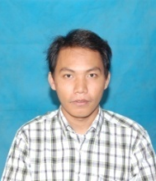
Name -Mg Arnt Myo Zaw
Date of Birth -9, 12, 1990
Place of Birth -Magway, Myanmar
Gender -Male
Material Status -Single
Height -5 feet 8 inches
Blood Type -O
Nationality -Burmese
Religion -Buddhist
Citizenship -Myanmar
Contact addresses - Prince of Songkla University, Phuket Campus, Phuket, Thailand, +66984066482
arntmyozaw@gmail.com
Education
- Bachelor Degree of Forestry and Environmental Science, University of Forestry and Environmental Science, Myanmar
- Master Degree in Environmental Management Technology, Prince of Songkla University, Phuket Campus, Thailand
Field of Expertise - Hey there! My name is Henry, and I am here to help anyone who needs translations from Burmese into English and vice versa. I am a native speaker of both languages, and I love translating. I am passionate about what I do, and I wholly dedicate myself to ensure the very best quality of work for my clients! Don't hesitate to get in touch with me and I'll try to help you!

