Aristides Bichara

+55 (21) 98206-4934

abicharatranslator@gmail.com

**Brazilian Freelance Translator** experienced in the following areas: Finance, Legal, Engineering, Oil & Gas, Renewable Energy, Marketing, Business Administration and Management, Education, IT, Automotive, Sustainability. Also performed Volunteer work in International Organizations (TWB and TED). Experience with online translation platforms.

### Experience

* Sesa Translations, Pangeanic BI, Kumpenny Solutions

### CAT Tools

* memoQ
* mem Source (TWB)
* Trados Studio
* MemCat
* SmartCat
* Caption Hub (TED)
* Subtitle Edit

### Languages Pairs

* EN-US > PT-BR
* EN-US > PT-EU
* ES-ES > PT-BR
* ES-ES > PT-EU
* FR-FR > PT-BR
* EN-US > FR-FR

### Languages Spoken

* Fluent English (C2)
* Fluent Spanish (C2)
* Fluent French (C2)

### Strenghts

* Commitment
* Adaptability
* Availability

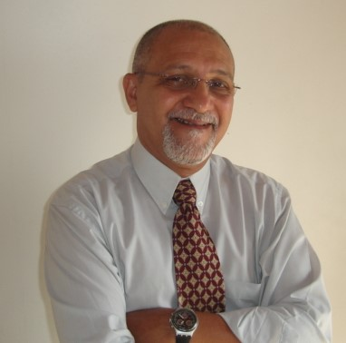

### Education

* BAccS in Accounting Sciences
* Post-Graduating in Business (FGV)

### Services Performed

Translation, Localization, Transcreation, Proofreading, MTPE, Subtitling.

### Daily Output

3.000 words p/day

3.000 TU p/sem (MTPE)

### Volunteer Jobs

* Translator Without Borders (5.623 words)
* TED Talks (3.787 words subtitled)

### Certificates

* Humanitarian Translation – TWB
* Volunteer Translator -TWB/Clear Global
* Introduction to Machine Translation and Post Editing – TWB/Clear Global