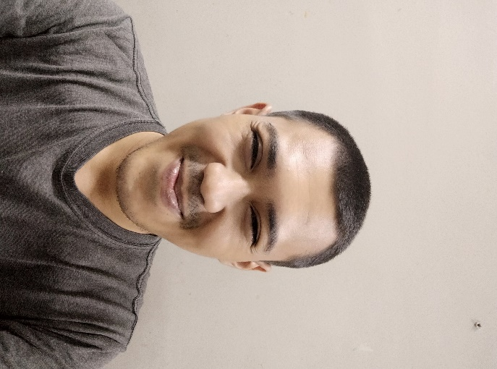 |  | EDUCATION
Senior High School 1 Way Jepara
2009-2012
Translante movie subtitle and make English article for international forum

State University of Surabaya
2012-2019
Translation book like novel and module in psychology major, make article for university and international journal
Argo setiawan  Translator  Profile  I am a freelance translator and have plenty of time so I can translate so many article, module and book. My age is 25years old, I am good at translation English to Indonesia and vice versa. My experience came from past year when I volunteree translate book and subtitle  CONTACT  PHONE:  +6282372998190  WEBSITE:  Instagram.com/argosetiawan_  EMAIL:  argosetiawan26@gmail.com |  | WORK EXPERIENCE
Jawa Pos Publisher Translator
2013–2014
My responsibilities is to translate international article to Indonesian for the company

Freelance Translator
2015–Present
I am translate subtitle for movie and comic from English to Indonesia

 |  | SKILLS

