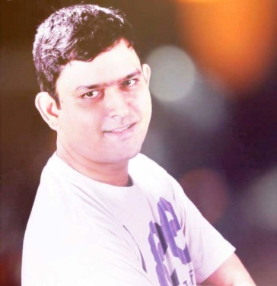
Anurag Sharma
Songwriter/Translator/Editor/VoiceOver Artist
rite2anurag@gmail.com | +918088087979 | Bengaluru, India

OBJECTIVE
I seek out opportunities that are both creative and challenging. I enjoy being part of those organizations or projects that help me explore my potential and make a difference to me professionally and personally.

EDUCATION
Masters in Business Administration (2008)
Bachelors in Pharmacy (2001)

Languages
Hindi – Native Proficiency
English – Conversational, Reading and Writing (Expert)

Skills
I am well-versed with the SDL Trados Studio 2015, MS Office suite, particularly Word and PowerPoint. I am comfortable with WordPress, Facebook, Instagram, and Twitter. Beginner but fast learner of social media marketing.

I am passionate about

Reading & Writing, Photography, Travelling, Running/Fitness, Quizzing, Exploring

WORK EXPERIENCE
- 2014 – Present
Freelance Lyrics Writer, Translator
(English-Hindi Pair / Hindi-English Pair) and Marketing Consultant (India)
Experienced in online media, with a focus on web content, blogs and reviews. Flexible to work on any topic. Very open to learning. Familiar with SEO and social media.
- 2012 – 2014
HDFC BANK
Worked as Sales Head, Credit Cards, Bangalore.
- 2008 - 2012
Worked at CREMA as Regional Business Head for Education Marketing
- 2001 – 2006
Worked as a Sales Officer in Nestle India.

currently associated with

OFFICIAL Lyrics Writer for PACE D RAPPER, Melbourne

SOWMYA TRANSLATORS
FOX STUDIOS DUBBING WORK
MEDICAL TRANCRIPTION

