1. Personal Information.
Name: Anucha Ngamyingmak
Gender: Male
Date of Birth: 10/01/1988
Age: 33
Nationality: Thai
Marital Status: Single
Career Level: Entry Level
Availability for working: Immediately Available
Expected Salary: Negotiable
My working character: positive thinking, ready for team working and having high inner energy for doing any work with all of my whole knowledge and efficiency.
Photo:
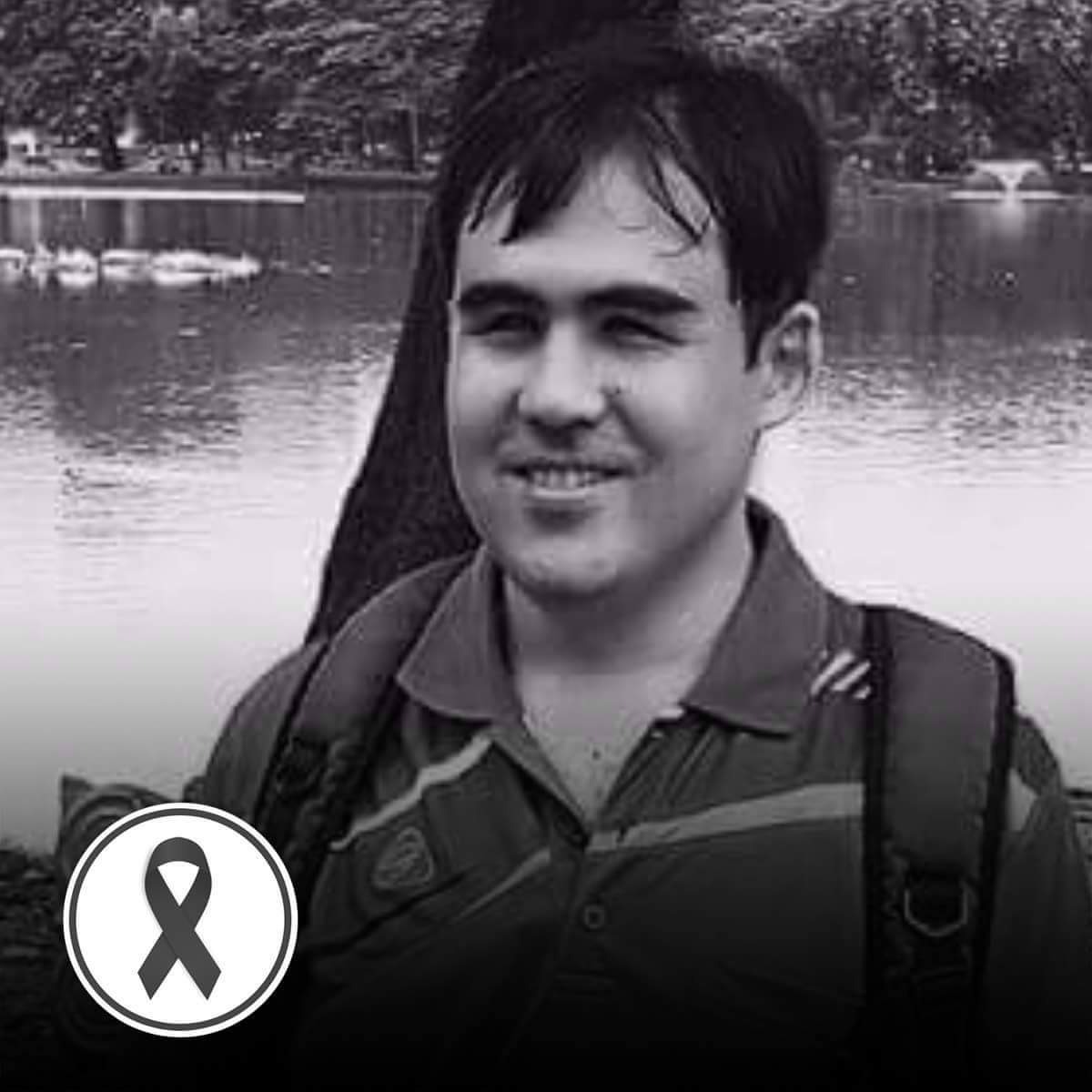

2. Contact Details.
Address:
Rachakarun Park Residence, 757 Somdej Phra Pinklao Road, Bangyikan, Bangpladt, 10700.
Mobile: 093-857-5109
e-mail: anucha.translator@gmail.com

3. Educational Information.
2018:
Thammasat University (Master Degree in English and Thai Translation)
Grade / GPA: 3.67
2007 - 2010:
Chiang mai university, bachelor degree (Humanities: Major in German, Minor in Philosophy)
Grade / GPA: 3.84
2001 - 2007
Samsenwittayalai School
Grade / GPA: 3.50

1994 - 2001
Bangkok School for the Blind.

4. Working Experience
2012: Ascott Sathorn
Position: Admin Officer
Responsibility: Restaurant reservation, Call Center and Internal document translation
2017 – Present: Grand Hyatt Erawan Bangkok
Position: Learning Coordinator
Responsibility: Training material creation and internal document translation
2019 – Present: 1000content Company
Position: Freelance Content Writer
Responsibility: Content creation for various topics and some translation tasks

2020: Book Translation
Name: “Hello Ruby: เริ่มวันสนุกกับโรบอตเพื่อนรัก”
Publisher: Nanmeebooks
Cover:
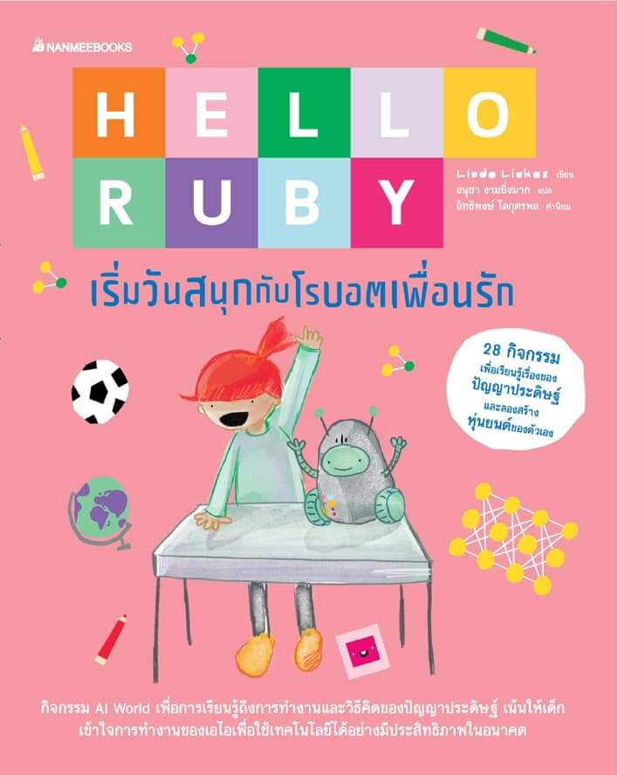

5. Skills.
Computer Skills:
- Typing (Thai/English)
- Microsoft Office Word
- Microsoft Office Excel (basic level)
- Internet and E-mail
Language Skill:
Spoken: English, German, Thai
Written: English, German, Thai
Translation: English-Thai, Thai-English

6. Other information:
I'm blind. However, I'm ready for working and ready to learn any new things and circumstance. I can use computer for working. I can read any documents which are in any file types such as word document (.doc) or pdf file, and I have any skill mentioned above. If you would like to ask for further information, you can contact me using information in section two of my CV.

