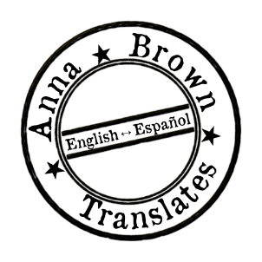
Anna Brown

Spanish to English Translator
Specializations: Science and Technology, Literary Translations
Folsom, CA, USA (GMT-8)
annabrowntranslates@gmail.com
annabrownntranslates.wordpress.com

SUMMARY OF QUALIFICATIONS

Languages
- English – native language
- Spanish – professional working proficiency

Software
- Microsoft Office 2013
- Across, MateCat, Memsource

Memberships
- Sigma Delta Pi – National Collegiate Hispanic Honor Society

EDUCATION

2009-2014 California State University, Sacramento
Bachelor of Arts in Spanish

2012-2013 Universidad de Valladolid, Spain
Study Abroad

2003-2008 Sierra College, Rocklin
Computer Science Major

RELATED EXPERIENCE

Nov. 2014-Present Self-Employed Freelance Spanish to English Translator
Provide quality Spanish to English translations, post-editing, editing, and proofreading for a variety of agencies, including: Type 2 Translate, Tomedes, Trusted Translations, Day Translations, and Translated.net

2012-2013 Translation Classes at the Universidad de Valladolid
- Theory and Practice of English/Spanish Translation
- Translation of Specialized Languages II (English/Spanish): Science and Technology
- Literary Translation I (English/Spanish): Prose
- Terminology and Translation

