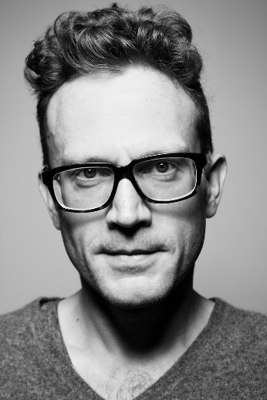

AREAS OF EXPERTISE

Translating legal
documents

Proofreading

Interpreting

Terminology

Multi lingual

European languages

PROFESSIONAL

First Aid Certificate

NVQ in Advice &
Guidance

PERSONAL SKILLS

Detail orientated

PERSONAL DETAILS

Andrew Cherednichenko
34 Made Up Road
Coventry
CV66 7RF
Curriculum Vitae

E-mail: blackboyxd@yandex.com

DOB: 10/06/1985
Driving license: Yes
Nationality: Ukrainian

Ukrainian-English pair: 0.03$
Russian-English: 0.03$
Ukrainian-Russian: 0.02$

Andrew Cherednichenko

Translator

PERSONAL SUMMARY

A multi-skilled, reliable & talented translator with a proven ability to translate written documents from a source language to a target language. A quick learner who can absorb new ideas & can communicate clearly & effectively with people from all social & professional backgrounds. Well mannered, articulate & fully aware of diversity & multicultural issues. Flexible in the ability to adapt to challenges when they arise & at the same time remaining aware of professional roles & boundaries.
Would like to work as a translator for a successful and ambitious company that offers great opportunities for career development and progression.

WORK EXPERIENCE

Interpreting Company – Coventry
TRANSLATOR June 2008 - 2015
Working freelance for a translation agency providing a translation and interpretation service to clients where needed. Involved converting documents and articles from one language into another and ensuring that the finished converted articles relay the intended message as clearly as possible.

Duties:
Researching legal & technical phraseology to ensure the correct translation is used.
Liaising with clients to discuss any unclear points.
Providing guidance & feedback & creating customer-specific style guides.
Translation of documents/letters from a foreign language to English & vice versa.
Reviewing and proofreading mother-tongue text.
Revising more junior translators' translations.
Conducting face-to-face interpreting.
Telephone interpreting.
Working as a translator for differents firms.
Supporting the translation team with other projects when necessary.
Excellent English speaking and writing skills.
Retrieving articles from newspapers, magazines & the internet & translating them into English.

KEY SKILLS AND COMPETENCIES

Familiar with translation software tools.
Able to fluently speak Ukrainian, English and Russian
Excellent communication and social skills.
Able to work to tight deadlines.
Highly skilled in Word, Excel and Microsoft Outlook.
Willing to travel and able to work under pressure.
Able to prioritise work.

ACADEMIC QUALIFICATIONS

BA (Hons) Translation Media & French
Nuneaton University 2005 - 2008

A levels: Maths (A) English (B) Technology (B) Science (C)
Coventry North School 2000 - 2005

REFERENCES – Available upon request.

