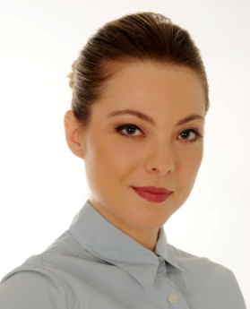
ANDREAKOPRIVICA

Address: Trillerstrasse 22/1, 08066 Zwickau
Phone: +49 1794133317
E-Mail: koprivicaandrea@gmail.com

WORK EXPERIENCE

04/2015 – 04/2018 Research coordinator
Radio Television of Serbia, Takovska 10, Belgrade, Serbia
- Viewing preference of target viewers group
- Telephone interviews with selected samples of viewers
- Writing television parameters reports and interpretation of audience data

09/2014 – 03/2015 School psychologist assistant volunteer
Elementary school “Svetozar Markovic”, HadziMilentijeva 62, Belgrade, Serbia
- Realization of professional orientation program
- Individual assessment – testing and interviews
- Data archiving, administration
- Individual and group conversations with students, teachers and parents
- Teacher’s evaluation
- Learning assistance to pupils with individual educational plan

09/2013 – 09/2014 Recruiting intern
Regional centre for talented children, Ustanicka 64, Belgrade, Serbia
- Talented children sourcing
- Recruiting, testing and selection
- Administrative support to director of the centre
- Mentorship, workshops

05/2013 – 06/2013 HR intern
01/2011 – 02/2011 National service for employment, Gundulicevvenac 23-25, Belgrade, Serbia
- Career orientation counselling for senior year students
- Selection of teacher job candidates for preschool and high school
- Self – efficiency training for unemployed REBT based
- Execution of candidate’s reference checks
- Conceptualization of job advertisements for the website

09/2010 – 12/2010 HR volunteer
Delta Holding doo, VladimiraPopovica 6, Belgrade, Serbia
- Recruiting and selection of job candidates

EDUCATION AND TRAINING

03/2018 - PhD in Work and Organizational Psychology

Faculty of Psychology, University of Vienna

10/2012 – 09/2013 Master of Science in Work and Organizational Psychology

Department of Psychology, Faculty of Philosophy, University of Belgrade

10/2004 – 03/2012 Bachelor of Science in Psychology

Department of Psychology, Faculty of Philosophy, University of Belgrade

09/2000 – 06/2004 High school

Nansemond River High school, Courtland, Virginia, USA

PERSONAL SKILLS

Computer skills MSOffice (advanced)

SPSS (good)

Arianna (advanced)

Languages Serbian – Mother tongue

English (C1)

German (B2)

Spanish (B1)

HOBBYS& INTEREST

Amateur poem writing, pastries making, hiking

