TRANSLATOR'S SUMMARY (EN>RU, DE>RU)

Anatolii Aleksandrov  Date of Birth: 1968  Residence: Ukraine  Contacts:  Skype: anteks91  Mobile Phone: +38-063-714-35-96  +38-050-343-82-84  E-mail address: Sibar-Sin@rambler.ru  Nichtwar@rambler.ru  Versuch@ukr.net | 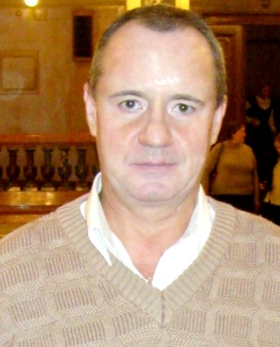

Goal: | To obtain an appointment of a freelance translator
Language combinations: | English-Russian  German-Russian
Field of expertise: | Technical translation of the following documentation:  - user manuals  - technical instruction manuals  - turbine engineering technical specifications  - equipment description and installation instructions  - iron & steel works  - technical drawings  - manufacturing documentation  - installation manuals, etc.
Years of work experience: | Over 30 years (since 1986)
Work Experience: | 2010 – Present: | KHTE TurboEngineering,  EN-RU, DE-RU Senior translator
 | 2003-2010: | GIPROSTAL Institute (Iron & Steel Works, Kharkov, Ukraine),  Translation Team Manager
 | 2002-2008: | Gulfstream Translation Agency (Kharkov, Ukraine),  EN-RU, DE-RU freelance translator
 | 1995-2003: | TURBOATOM (Turbine Manufacturing Works, Kharkov, Ukraine),  EN-RU, DE-RU translator
 | 1986-1994: | Army service, civilian employee in Germany
Education: | - National Karazin University of Kharkov (Ukraine)  - One Semester Study at Friedrich-Schiller-University, Jena (Germany) – referent translator
Native Language: | Russian
Foreign Languages: | English – proficient  German – proficient
Computer Skills: | CAT-tools: SDL Trados Studio 2011, SDL Trados 2007  Software: MS Office (Word)
Additional Data: | - Practical 4-year-job in Germany  - Business trips to Egypt  - Work on hydro schemes in India (Tehri HPP, Largi HPP)  - Special fields: turbine engineering, iron & steel works
Rates: | About 0.05 EUR per source word (to be negotiated)
Capacity: | 1 000 words per day
Availability: | 8:00 a.m. – 5:00 p.m. (GMT+2) Monday to Friday

