Name and surname: Ana Miljković 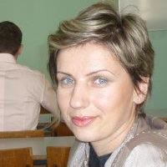
Address: 11 Patrisa Lumumbe, 18000 Niš
Country: Serbia
Date of birth: 15.05.1983.
Tel: 063 1 24 85 11
E-mail: ana83miljkovic@yahoo.com

Education:
- Faculty of Philosophy in Niš – department of the English language and literature (2008)
- High school B. Stankovic in Vranje (1998-2002), language department
Language competence:
- English
- French B2
Computer skills:
- MS Office
- Internet
Work experience:
- (2006-2008) Fair play- school of foreign languages
Position – English language teacher
- (October 2008) primary school Dušan Radović in Niš
- Position – English language teacher
- (2009-2011) primary school Vožd Karađorđe in Alekasinac
Position – French language teacher
- (2012) English for you- English language school
Position – English language teacher
- (October 2013- August 2014) Hospitality and Tourism school in Niš
Position – English language teacher
- (2015) Speak up – school of foreign languages
- Position – English language teacher
- (2015 – up to present ) Translation (Serbian to English, English to Serbian) of doctorate papers, including different fields such as mechanical and civil engineering, medicine, technology of wine and herbs.
Profile:
- Driving license B category
- Hobbies – reading, learning foreign languages, fitness and walking, climbing.
- Characteristics – decisive and responsible person, team work oriented, ready to learn

