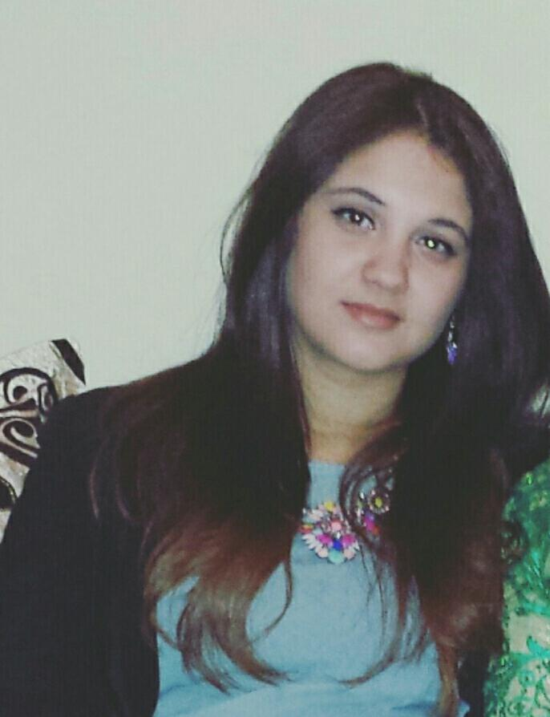
Curriculum Vitae
Name : Amira
Last name : Guesmi
Nationality : Tunisian
Birthday : 18 april 1989
Address : 54, Avenue Mohamed Bejaoui 8160,
Ghardimaou, Jendouba ,Tunisia.
Current Location: El Manzeh 5, Tunis, Tunisia.
Phone Number : (+216) 55443562
E-mail : amira.guesmi@fulbrightmail.org
ameera.guesmi@gamil.com

Education and Qualifications:
- 2014-2016: Master degree in linguistics in the Faculty of Letters, arts and humanities of Manouba (working on thesis).
- 2011: Bachelor Degree (licence) in the English language, literature and civilization. Faculty of Letters, Arts and Humanities of Manouba.
- 2008: Baccalaureate certificate: Experimental Sciences, principal session.

Work Experience:
- Freelance note taker/Translator/Interpreter :
-Worked with IOM (International Organization for Migration) on several meetings and workshops.
-Translating literal and technical documents from Arabic to English- English to Arabic.
- March-June 2016: Specialized researcher with the Navanti Group, LLC, Virginia, USA.
- translate, analyze, and write short reports and summaries based on social and traditional media.
- February –November 2015: Arabic Instructor for American Students in School of International Training, Tunisia (World Learning).
-Teach the Arabic Language to American Students.
-Prepare and Grade Exams.
-Help students draft their blogs in Arabic.
-Report students’ progress to the program coordinator.
- October - December 2014: Interpreter/Assistant with the Carter Centre.
-Provide simultaneous interpretation (Arabic/English) as needed.
-Provide written translation (Arabic/English) of documents on a wide range of programmatic areas if required.
-Assist with setting up meetings with local election administration counterparts if required.
-Accompany the short-term observers on their regional travels in Tunisia and stay with them during the trip.
- September 2014: Business English Instructor at ENIT.
-Teach and prepare future engineers for the job market through mastering the technics of communicating in English.
- 2013-2014: Fulbright scholar: Teaching assistant for Arabic at Chapman University, Orange County, California, USA.
-Assist faculty members with classroom instruction, exams, and record keeping.
-Tutor or mentor students.
-Obtain materials needed for classes, including texts and other materials.
-Prepare presentations for lectures.
-Create and write materials such as syllabus, visual aids, answer keys and course website.
-Correspond with students on Blackboard.
-Take attendance and record responses.

Conferences and Trainings:
- 25 February 2015: Co-interviewing in the Thomas Jefferson Jury Board.
- 30 January 2014 in the United Nations Headquarters New York: assisted in Committee on Teaching about the United Nations (CTAUN) “Promoting Peace through Education”.
- 2010: certificate of summer training LVN ( Language Village in Nabeul –Tunisia)

Computer Skills:
- Word, Excel, PowerPoint, Internet, etc.
Languages:
- Arabic: fluent written and spoken (mother tongue).
- English: Fluent written and spoken.
- French: intermediate.
- German: basic.

