Europass  Curriculum Vitae |  | 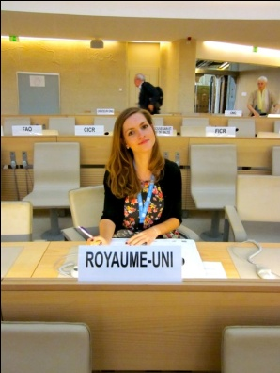
Personal information
Surname(s) / First name(s) |  | Potter, Alison Helen
Address(es) |  | 90 Wellington Road, Wilsden, Bradford, West Yorkshire, BD15 0LX
Telephone(s) |  | +44 1535 275628 |  |  |  |  |  |  | Mobile: |  |  |  |  | +447587727003
E-mail |  | a.h.potter@ncl.ac.uk
Nationality |  | British
Date of birth |  | 31/12/1989
Gender |  | Female
Desired employment / Occupational field |  | Freelance Translation
Work experience
Dates |  | February - August 2011
Occupation or position held |  | Co-monitor + Translator and Interpreter
Main activities and responsibilities |  | Monitoring of Human Rights Sessions at the UN, Geneva Translation of notes gathered for the website and Interpreting at expert seminars on Transitional Justice and Humanitarian Law.
Name and address of employer |  | Adrien-Claude Zoller, 14 Rue du Mail, Genève, la Suisse.
Type of business or sector |  | International Law, International training.
Dates  Occupation or position held |  | June – December 2011  Co-writer, Translator, Interpreter and Social Worker
Main activities and responsibilities |  | Co-writing of a book, a detailed analysis of the process of reintegration of ex-combatants in Colombia and for this, conducting of interviews, research etc. Unofficial translating of documents and correspondence between the Colombian Government and the European Union (the organisation’s sponsor). Interpreting via skype (only 1 day).
Name and address of employer |  | Solange Pachón, calle 13 con carrera 8, Bogotá Colombia.
Type of business or sector  Education and training |  | Transitional Justice/Social Work.
Dates |  | 2008 – 2012
Name and type of organisation providing education and training |  | Degree in Modern Languages and Politics at the University of Newcastle (Year in industry was taken)
Dates |  | February – August 2011
Name and type of organisation providing education and training |  | Course in International Humanitarian Law and the United Nations system.
Mother tongue(s) |  | English
Other language(s)
Self-assessment |  |  | Understanding |  |  |  |  |  |  |  | Speaking |  |  |  |  |  | Writing
 |  |  | Listening |  |  | Reading |  |  |  |  | Spoken interaction |  | Spoken production
Language |  |  | 8 |  | Spanish | 9 |  | Spanish |  |  | 8 | Spanish | 8 |  |  | Spanish | 7 | Spanish
Language |  |  | 7 |  | French | 9 |  | French |  |  | 7 | French | 7 |  |  | French | 6 | French
 |  |  | 7 | Portuguese |  | 9 | Portuguese |  |  | 7 |  | Portuguese | 8 |  | Portuguese |  | 7 | Portuguese
Social skills and competences |  | I am a very compatible person, great with communication with an eagerness to please.
Organisational skills and competences |  | Very organised when it comes to work, willing to work through the night for deadlines.
Technical skills and competences |  | Very experienced in Word, including comment/track change system for legal contracts.
Computer skills and competences |  | Skype, Word, Excel, Pdf
Artistic skills and competences |  | Literature studies, always achieved A grade in English both writing and reading.
Other skills and competences |  | Piano
Driving licence |  | UK manual
Additional information |  | Willing to complete a short translation test.

