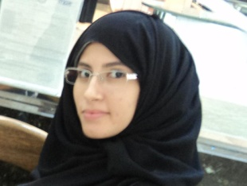
Alaa Mahmoud Mahfouz
Address: Egypt ,Cairo , 11 Al Shaheed Mahmoud Desouky St.
City and State: Cairo , 6 October
Mobile Telephone : 0020-148886890
E-mail : Sensitive.Rose@live.com
DOB: 15th.June.1991
Born : Qatar , Al Doha
Marital Status : Single
Nationality : Egyptian
Profile and Objective

I consider myself a very insisting serious person in many things especially in proving myself in my work and study , in the same time I love to enjoy the moment and being full of hope of the future which allows me to feel comfortable about what's coming , smart , funny and very interested in learning new things and getting a lot of experience that will effect me through my life …
Objective
Is to have the chance to be In a great place that would give me the maximum experience to improve my skills and always learning from other qualified people and to make a good progress and a difference to the company or the group am working with
Education

Science College – Suez Canal Univercity , Biochemisty
Class Of 2009
Languages
Arabic : Mother Tongue
English : Excellent Written and Spoken
Spanish : Poor
Computer Skills
ICDL : An excellent use of Microsoft Office
Windows Movie Maker : Excellent use which filled with creativity
Programming: C++ Language from Computer Science at Carnegie Mellon University in Qatar
A very good ability of surfing and making searchs about anything and analysis it to a fine result .
Courses
In Human Resources : which gives me more ideas and concepts about successs and how to face life and get over the hard times .
3 Hours course in how to organize your life .
3 hours course in making your plans done .
3 hourse course in weill corniell in Qatar about the importance of medicine to our life
4 hours course in IT and web development
Community Voulenteerism :
In Green Peace Organization
In Resala Society : that helps the poor people who need a lot of attention on they health and education and the social factor
Hobbies and Interests
Reading in Politics , Novels and HR
Listetning To Old Music which makes me rest my mind
The most 2 sports I enjoy playing them is running and Youga .
Meeting new people give me the chance to be more experienced and become helping to a lot of people when they ask for it and to raise my social IQ that would be more important to a human being to deal with people and learn from them next to the good times and fun we get
Making projects in matter of physics which give me the inspiration to think differently with a complete open mind to what sometimes eyes cant believe , it's sort of a motivation to my soul .

