Personal Information
Name: Ahmed Tarek Attia Farag
Birth Date: May 13, 1991 | 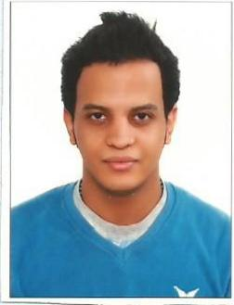
Nationality: | Egyptian

Contact Information
Home Phone: | 00380631499809
Mobile Phone: | 00380631499809
Email Address: | ahmedtarektito@gmail.com
Address: | konavaltsa 118- ivano frankvisk- ukraine
SKYPE: ahmedtarek48
Career Objective
Position Sought: | Copywriter - translator

Education
Institution | Degree - Major | Completion Date
ivano-frankvisk oil and gas university  ivano-frankvisk national university of oil and gas | Bachelor petroleum engineer  Operator production oil and gas | 2015
American high school | certificate high school | 2010
Cairo University | convince clients.workshop | 2009
Ain shames university | building team work.workshop | 2009

Skills
Skill | Skill Level
microsoft word | very good
microsoft excel | very good
microsoft power point | very good
mathcad | good

Languages
Language | Skill Level
Arabic | native
English | fluent
Ukrainian | excellent
Russian | very good
Frensh | fair
Germen | Fair

