**Ahmed Saif Khalfan Ali Al-Mejrafi**

AL Dhahira, Ibri, Oman

Cell: +968-96586880

E-mail: ahmed.almejerfi@gmail.com

Website: <https://ahmedalmejerfi.wixsite.com/translatopia>

YouTube: <https://www.youtube.com/channel/UCeo6dyQfjOQQZtQETk-sy6w>

**Objective**

Apply for a job.

**Education**

**-** Bachelor in English Literature. College of Arts and Social Sciences. Sultan Qaboos University. September 2019.

- Certificate for General Education Diploma, Omar Bin Masoud School, Al Dahira. June 2012

**Projects**

Research Project on Adding English Literature to Omani School Curriculum.

**Work and Other Contributions**

* Working as Audio-visual translator from May, 2019
* Still working in “Al’mataib Shop” as Cashier from 2018.
* Acting a major role in “Hot Potato” play in English theater at SQU, 2018.
* Responsible for ETS’ Closing Committee in December 2017.
* Participating in the 10th Translation Forum.
* Volunteer in "The 17th Oman International ELT Conference", 2017.
* Working as a translator from, 2016.
* Acting a major role in “Night at the Library” play in English theater at SQU, 2016.
* Member of Decoration Committee of "The Mexican Cultural Week Event" at SQU, 2016.
* 2nd place in Gulf University Theatre competition, 2016
* Organizer in "The Second English and Translation Forum", 2015.
* Attended Advanced Speaking Course, 2015.
* Attended General Speaking Courses, 2015
* Presenter of "Korean cultural week", 2014.
* Attended General Speaking Courses in, 2014,
* Participating in 1st English and Translation Forum in the academic year of 2013/2014.
* Participating in Brazilian Culture Day in the academic year of 2013/2014.
* Volunteering at the 13th Oman International English Language Teaching Conference from 17 to 18 April, 2013.
* Attended General Speaking Course, 2013.
* Participating in the 17th Annual Open Day.
* Participating in “Atta Wa Igada’s” summer activities, 2011/2012.
* Certificate of appreciation for being excellent the first semester in Omar bin Masood school in 2011/2012.
* 3rd place in Olympic Games, 400 m, in Oman, 2011.
* Participating in summer activities under the name “Sayfi Namaa” in 2011.
* Participating in “Be a Volunteer” campaign activities in 2011.
* Participating in summer activities which is organized by the ministry of education under the name “Sayfi Affzal” in 2010.
* Participating in the Open Theatre, 2003

**Workshop:**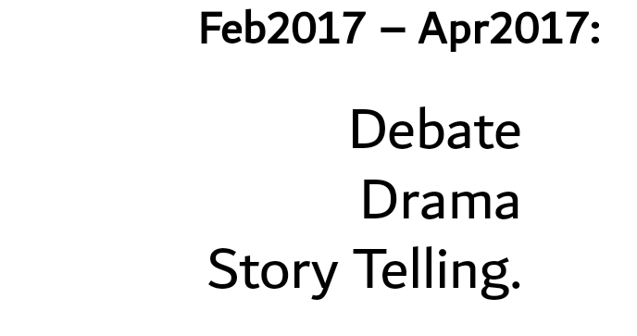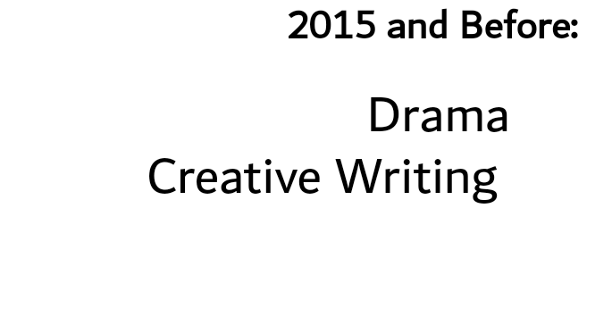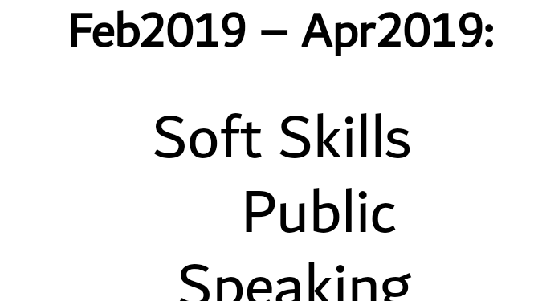

**Additional Skills:**

* Computer skills: Microsoft Word and PowerPoint
* Translating programs: Subtitle Workshop – Subtitle Edit - Aegisub
* Designing blogs: Wix website

**Interpersonal Skills:**

* Communication skills
* Teamwork
* Self-motivation
* Conflict resolution
* Time management
* Adaptability
* Decision-making
* Soft skills and hard skills
* Typing speed

**Language skills**

* Arabic: Mother tongue.
* English: Fluent.

**Interests and Hobbies**

* Acting
* Reading
* Writing: stories and poems
* Translating

**Reference**

Dr. Fathiya Al Rashdi, Assistant Professor

Department of English/ College of Arts and Social Sciences

Sultan Qaboos University

E-mail: [rfathiya@squ.edu.om](mailto:rfathiya@squ.edu.om)

Phone Number: +968 99856552

Dr. Kirsten Hemmy, PhD

Department of English/ College of Arts and Social Sciences

Sultan Qaboos University

E-mail: [kabadji@squ.edu.om](mailto:kabadji@squ.edu.om)

Phone Number: +968 91723508

**Relatives**

Adil Saif Ali Almejerfi: +968 91196445