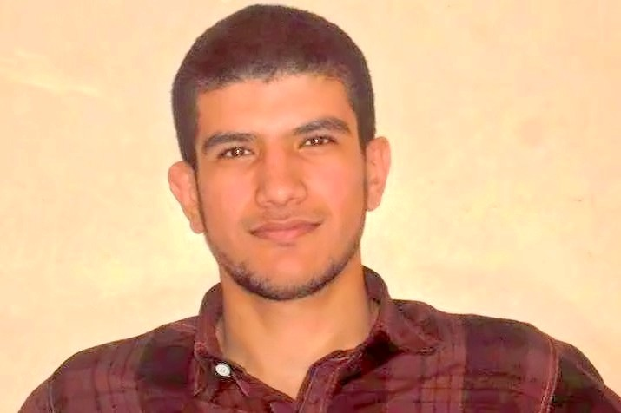 Ahmad Abdullah Shehata
Senior Translator & Proofreader
English » Arabic
El-Mahalla El-kubra, Egypt
- About Me:
I am Ahmad Shehata, a highly professional and experienced native Arabic Translator. I have the necessary linguistic talents and academic qualifications to provide you with high quality English » Arabic Translation. I don’t actually accept any job unless I am confident that I will handle it professionally and efficiently.
- Personal Qualifications:
-Ability to develop, execute, coordinate, analyze and recognize problems.
-Excellent team player, self‐motivated and proactive.
-Ability to work under work pressure with ease and efficiency.
-Good organizational skills.
-Enthusiastic and creative individual, accurate, adaptable, broad‐minded, creative, dependable, efficient, energetic, experienced, honest, keen for details, loyal, quick learner, and self‐motivated High presentation skills.
-Excellent computer and Internet skills.
-Excellent interpersonal skills.
- My objectives:
my objectives include providing my clients with high-quality translations, developing my experience, enhancing my academic background and learn about everything in the field.
- Education:
faculty of languages and translation, Al-Azhar university.
Department: English department, Islamic branch.
- Services:
Translation, Proofreading, Editing, Teaching.
- Areas of Expertise:
Political studies, Journalism, TV, Technology, literature, Educational Certificates (Universities and Schools), Childcare, Computers & Information Technology, Cultural issues & studies, Articles and general translation.
- Software:
MS Word 2010, Adobe reader, Foxit reader, Internet applications, Picasa, and many other applications.
- 8- OS:
Windows 8.1
Windows XP
- Contact details:
Cell phone: +201011944315
E-mail: TR.Ahmad.Shehata@gmail.com
Skype: Ahmad.Shehata22

