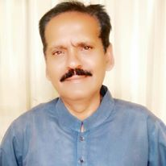
AFTAB AHMED G. CHANNA
Address: New Pind Islam Colony Sukkur
Cell # 0312-3482198, 0333-7141478
E-mail: aftabchannaa@gmail.com

INTEREST: Education, Advocacy, Leadership, Management and Public Relations
Education | Special Skills
- Masters in Political Science (1987-1989) Shah Abdul Latif University- Khairpur, Sindh, Pakistan Areas of Study: Western Political Thought, Muslin Political though, Comparative and Developmental Politics, International Relations, Genesis of Pakistan and Research Methodology.  - Masters in Sindhi Literature (1989-1991) Shah Abdul Latif University- Khairpur, Sindh, Pakistan Areas of Study: Forms of Classical poetry, Folk poetry, Literary Criticism, Aruzi, forms of Modern poetry, Evaluation of classical literature, Folk Literature, Shah Latif and General Linguistic.  - Bachelors in Law (1993-1996) Shah Abdul Latif University Khairpur Areas of Study: Constitutional Law, International Law, Mercantile Law, Pakistan Panel Code, Muhammadan Jurisprudence, English Jurisprudence, Common Law, Business Law (PPC, CPC, CrPC) and Qanoon-e-Shahadat  - Bachelors in Education (1991-1992) Allama Iqbal Open University Islamabad Areas of study: Perspective of Education, School Organization, Human Development and Learning, Educational Measurement & Evaluation, Curriculum & Instructions, Educational Technology, Advanced Education, Research Techniques and Comparative Education.  - C.T Training Course (1993) Bureau of C & E Wing, University of Sindh, Jamshoro Areas of Study: Early Childhood Education trainings and Teachers Trainings.  - B.A -Bachelor of Arts (Sociology) (1985-1987) Shah Abdul Latif University- Khairpur, Sindh, Pakistan Areas of Study: Sociology, International Relations and Political Science. | - Advocacy, mobilizing and public speaking  - Project Management and Coordination  - Training skills  - News/Story writing skills  - Drafting, Editing  - Strong Leadership skills  - Strong inter-personal, intra-personal and mass-communication skills  - Strong public relation skills  - Excellent English skills, oral and written.  - Proficient in Microsoft Office and other computer software applications for print and visual Journalism  - Fluent in English Urdu, Sindhi, Punjabi and Siraiki  - Office administration skills as well as scheduling using Outlook Effective office management.  - Teaching, guidance and counseling skills.

Academic testimonials will be provided if requested.
I posses experience as a teacher, trainer, coordinator, public speaker

Experience Description | Trainings Attended
PAKISTAN INSTITUTE OF DEVELOPMENT ECONOMICS (PIDE)  Supervisor  ("Understanding Pakistanis" Project)  From 18.07.2022 To 21.08.2022  Conducted 160 Interviews along with supervising field staff in 6 Districts of Sindh viz Sukkur, Ghotki, Shikarpur, Kasmor@Kandhkot, Jecobabad and Kamber Shehdad kot..  Continued Translation and Transcription till 01.08.2022.  OPM Oxford Policy Management  Moderator/Note Taker  (HEART SENSA 4 Project)  15.07.2019 to 10.08.2019)  Conducted FGDs IDIs and KIIs, in two Districts of Sindh viz Khairpur and District Kambar shehdadkot.  Transcripted FGDS, IDIs and KIIs  OPM Oxford Policy Management  Moderator/Note Taker  (PNCP-Third party beneficiary feedback operational review and monitoring Project)  (02.07.2019 to 14.07.2019)  Conducted FGDs IDIs and KIIs, in two Districts of Sindh viz Kandhkot@Kashmor and District Larkana.  Transcripted FGDS, IDIs and KIIs  OPM Oxford Policy Management  Moderator/Note Taker  (Lady Health Worker(LHW) Evolution Project)  (12.05.2019 to 8.6.2019)  Conducted FGDs IDIs and KIIs, in two Districts of Sindh viz Matiari and District Kashmor.  Transcripted FGDS, IDIs and KIIs  OPM Oxford Policy Management  Enumerator  (BISP Impact Evolution Project)  (2.03.2019 to 06.05.2019)  Conducted survey using Tablet in District Sukkur.  OPM Oxford Policy Management  Moderator/Note Taker  (Fortified Food Project)  (25.01.2019 to 27.02.2019)  Conducted FGDs IDIs and KIIs, in three Districts of Sindh viz Karach, Hyderabad and District Sukkur.  Transcripted FGDS, IDIs and KIIs.  OPM Oxford Policy Management  Note Taker/ Moderator  (10.04.2018 To 10.06.2018)  Moderated, transcripted and translated in English from sindhi/urdu language FGD, KIIs and IDIS in three districts of sindh viz Hyderabad, Mithi and Karachi  OPM Oxford Policy Management  Note Taker/ Moderator /Translator  (17.10.2017 To 02.12.2017)  Moderated, transcripted and translated in English from sindhi/urdu language FGD, KIIs and IDIS in six districts of sindh viz Sukkur, Larkana, Nawabshah, Hyderabad, Mithi and Karachi  World Vision Pakistan  Facilitator/Translator (25.09.2017 to 27.09.2017)  Conducted FGDs in three Talukas ie Rohri, saleh pat and Pano aqil of District Sukkur  Transcripted FGDS From Sindhi to English language.  Marketing Research Beauru  - Interviewer (10.08.2017 t0 31.08.2017)  Health Survey  Interviews with Medical Officers at Sukkur  Pakistan Centre for Philanthropy Islamabad  (From 20 June 2017 to 5 July 2017)  - Facilitator Focal Group Discussions  Translation of FGDs from Urdu, sindhi to Englis  Population Council  - Interviewer (1.2.2017 to 8.3.2017)  Base Line Survey, The International Men & Gender Equality survey (IMAGES) Three Districts Hyderabad, Umer kot and Jacobabad.  Conduct and transcript Interviews, KIIs and FGDs  Population Council  - Facilitator (10 March 2016 to 30 April 2016  Area of work: Transcribed Focus Group Discussions at Sukkur  Haglar and Balley  - Interviewer (27 October 2015 to 30 November 2015)  Area of work: Conducted Interviews from Doctors and Health Facilities)  Arshad, Arjumand and Associates (AAA)  - Transcriber/Translator for Focus Group Discussions (15th August 2015 to 15 September 2015)  Indus Resource Center Khairpur  - Nutrition Assistant (April 26, 2013 – September 30, 2013)  Areas of work: Nutrition project in Shikarpur District.  Help Age International,Pakistan  - Social Mobilizer (Feb 24, 2013 – April 20, 2013)  Areas of work: NFI Distribution in Shikarpur District.  Indus Resource Center Khairpur  - Community Mobilizer (Novermber 19, 2012 – January 31, 2013)  Areas of work: Nutrition Project in Shikarpur District.  ACTED International,Pakistan  - Community Moblizer (April 28, 2011 –December 15, 2011)  Areas of work: Shelter Project in Shikarpur and Kandhkot Districts.  World Vision International,Pakistan  - Health & Hygiene Promoter (October 02, 2010 – January 31, 2011)  Areas of work: Wash Project in Sukkur and Khairpur Districts.  Anjum Asim Shahid Associates  - Supervisor (April 13, 2010 – June 07,2010)  Areas of work: Education Project in Khairpur and Dadu Districts.  Population Council Islamabad  - Logistic Supervisor (February 02, 2008 – April 27, 2008)  Areas of work: FALAH Project in Sukkur and Ghotki District.  Marvi Rural Development Organization MRDO  - Social Mobilizer (October 01, 2008 – October 24, 2009)  Areas of work: Education Project in Sukkur and Khairpur Districts.  Government of Sindh  - Junior School teacher (November 28,1988 –June 30,1998)  Areas of work: Early Childhood Education in Sukkur District. | Five days Training for Community Mobilization From 28.04.2011 to 04.05.2011 Organized by ACTED Pakistan at Shikarpur.  Orientation training workshop on child protection on 28.10.2010 organized by World Vision International-Pakistan  One week training on Mobilization from World Bank From 03rd April to 10th April 2010  Eleven days base line survey training (Twice) from Population Council Islamabad for Family Advancement for Life and Health (FALAH) Project. (In February 2008 and October 2009).  Having obtained One week training from R cons (Research consultants) for the project of World Bank and P.P.A.F. for poverty elevation (October 2008)  Having received necessary trainings for relevant projects  . 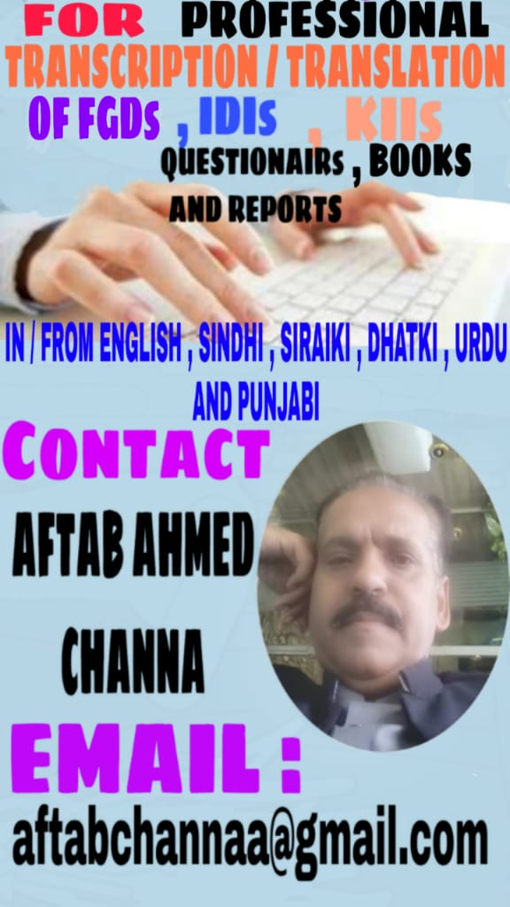
COMPUTER SKILLS
MS Word, Excel, Power point.
Installation, Maintenance, Troubleshooting of Windows (XP, Win7 &8)
LANGUAGES:
Sindhi, Urdu, Siraiki, Punjabi, English
REFERENCES

- Mr. Muhammad Ashraf
Senior Program Officer
Pakistan Centre for Philanthropy Islamabad
Email: mashraf@pcp.org.pk
Cell# 0333- 5108988

- Mr. Abdul Haq Khoso
Monitoring & Evolution Officer for Sindh
Oxford Policy Management (OPM) Islamabad
Email: haque.baloch@gmail.com
Cell# 0333 7113110
0312 8389605

PERSONAL INFORMATION:
Father’s Name Ghous Bux M. Channa
Date of Birth 13-03-1967
CNIC 45504-2346602-5
Domicile District Sukkur (Urban), Sindh
Marital status Married
I, hereby declare that all data and information mentioned above are all corrected true to the best of my memory.

