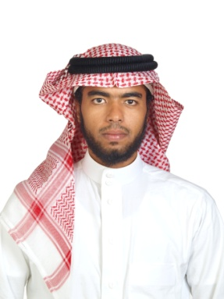
Abdul-Aziz Omar Alsomadani
D.O.B: 03/03/1988
Mobile: +966535256562
E-mail: alkonz24@hotmail.com

Seeking a challenging position in customer service or public relations or in a computer field, in general a job environment where I can put my English and computer skills to good use.
Education:
- Foundation study program, South Australian universities, Australia, 2009.
- High school, natural sciences, falasteen secondary school, K.S.A, Jed, 2005.
Training:
- English program, Multimedia University Malaysia, 2006.
- English program, Eynesbury College, Australia 2009.
- Computer Application training, International computer institute, K.S.A, 2003.
- MS - front-page 2000 training al-mashura institute, K.S.A, 2004.
- Windows 98 & word 97 training, al-mashura institute K.S.A, 2000.
Skills:
- Good background of Microsoft office, internet and outlook.
- Ability to work well in a group or individually.
- Good communication in English and Arabic, confidently and objectively.
Experience:
- No previous experience.
Interests:
- Football, swimming, athletics, movies, internet and traveling.
References: upon request

