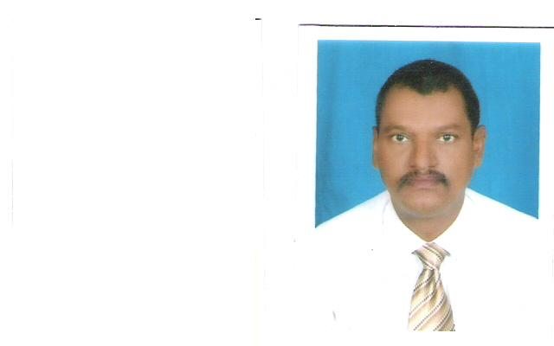

Contacts Details : Active cell phones +249912365681 ___+249123065681
: E-mail address :ghaffarhakim65@gmail.com

C.V/Resume

Personal Information
• Name : Abdel ghaffar Ahmed Mustafa Ahmed .
• Date & place of Birth : 1965 , El_damar/Sudan(River Nile state ).
• Nationality : Sudanese .
• Martial Status : Married
• Languages :Arabic (Mother Tongue )- English(writing ,reading , fluently speaking and
listening ).
• CurrentAddress : Sudan - Khartoum North(Block 2 , House No. 924).

Educational Qualifications
• Bachelor Degree in Economics (Business Administration ),University of Khartoum
(1990).
• Master Degree in Business Administration (MBA),University of Khartoum (2007).
- Master Degree in Arts (Translation)- 2014/2015 (Faculty of Linguistics /University of Sudan for Sciences &Technology ).
• Higher Diploma in Development &Planning(Projects planning&Evaluation) Cairo (INP).
• Professional Diploma in management of Non-Governmental Organizations(NGOs)UMST.
• Computer Courses (operations ,word processing packages,Programming languages).
• Systems Analysis and Design courses .
• English Language Advance Communication Course(Cambridge TrainingCentre , Sudan ).

Professional Working Experience

Former Employer : : Emirate Gulf Dawn Translation Services(EGDTs) , United Arab Emirates, from 2011-2014 :(Professional Translator)(English><Arabic)
Former Employer : : The Carter Center (TCC)- INGO ,Sudan Office , Sudan Democracy Program ( 2010 Sudanese Elections (International Observation Mission) ,Referendum 2011 , Translator & Interpreter )(English><Arabic)-for International Observers ..

Former Employer : : Arabian Institute for Financial and Administrative Studies (AIFS) , Sultanate Of Oman , Batana , Al-siwaiq State 2011-2012:(Training Supervisor and Translator)(English><Arabic)

Reference

2 . Lawyer / Babiker Mustafa Al-hag : UAE –Abu Dubai ( Emirates Gulf dawn Translation Services) (EGDTs) ,, Legal Translator , Email : lawyerbabiker@gmail.com>
Tel : 00971503351833

