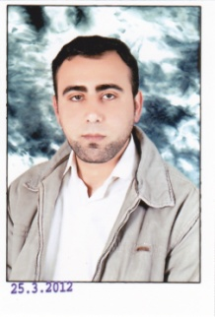
Personal Data:
- Name: Abdullah Hamed Mohamed Hatel.
- Date: 05/09/1983
- Address: Aga, Dakahlia
- Military status: exempted
- Marital status: married
- Phone: 01120070508 / 01018934375
- E-Mail: abdallahhmed9@gmail.com.
Education Data:
- University: El Azher
- College: language and translation
- Department: simultaneous interpreting English
- Degree: good
- Year: June 2006
Experience Data:
- Oxford Company for language and computer as (translator from English to Arabic and Arabic to English )from 11/2006 untill now
Skills
- Computer (word, excel, internet)
Language:
- Arabic: mother language
- English: second (excellent in four skills(speaking, reading, learning and writing)

