Name : : Rekha Valluri
Address : 1-11-226/2, G-1 Saimahal Apartments,
Road No 5, Begumpet,
Hyderabad – 500 016

Mobile Phone: +919618696666

Email ID : rekha.valluri@gmail.com or rekha.translations@gmail.com

Educational Qualifications

- Bachelor in German form Pune university studied German Literature & Language at SP College and Department of Foreign Languages.
- Masters in English Literature from Pune University
- Diploma Holder in Italian

Experience

- Worked as a German translator for Greaves Group company in Pune. Ruston & Hornsby. The company manufactured marine engines and had collaboration with Benz Motors (MWM) Motoren Werke Mannheim.
I was responsible for the translation of the complete know how

- Worked as a freelance translator for Bajaj tempo who had a collaboration with Zahnrad Fabrik for the manufacture of gears.
Was responsible for the complete know how translation. Also translated many technology documents for Bajaj Tempo for the Daimler Benz project.

- Worked as a freelance translator for Thermax Pvt Ltd , Vulcan Laval and many German collaborated industries in Pune.

- Was responsible for the complete translation of the warhead technology for Bhart Dynamics Limited.

- Have been responsible personally for a massive translation assignment of BMW for Accenture. The project involved a translation of about 100lakh words so far.

- Have translated documents for Allianz Insurance and many German projects of Accenture.

- Have handled translation of research documents patents, product literature standardsetc for many laboratories, research organizations, pharmaceuticals companies etc.

- I thus have a cumulative experience of over 25 years in German translations

I have a near nativeexpertise and an excellent control over German language and English and can execute any critical project with utmost flair My personal capacity is about 25,000 to 30,000 words per day, if I dedicate may self solely to one project.

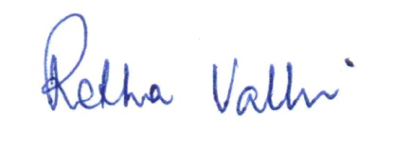
Rekha Valluri

Date : 07.08.2013
Place : Hyderabad

