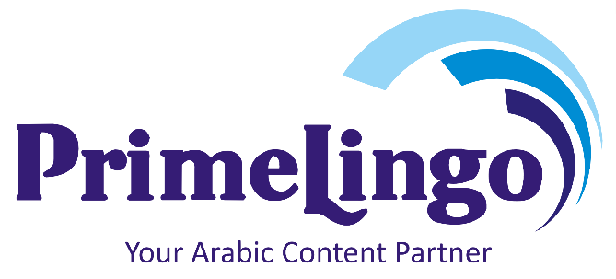

**Company Profile**

 +20 1014993375

[ info@prime-lingo.com](mailto:# islamelsakhawy@gmail.com)

 Alexandria, Egypt.

PrimeLingo is a professional translation and localization services agency that specialized in English to Arabic solutions. Our team of professional translators is very talented and creative, with supreme qualifications to back them up. They’re skilled linguists with much expertise in subject matter.

Our esteemed C.E.O./Founder has over 15 years of experience in the translation and localization services in various fields. He singlehandedly built this company armed with his superior language skills and work ethic, and he carefully selected and recruited the right staff to achieve the vision of the company.

**Goals**

We aim to help global businesses laying the groundwork in the Middle East and North Africa region, by using translated materials as its concrete. Our gifted team of translators and localizers work really hard for PrimeLingo to become a prominent translation services company provider that’s very well known to the world and the biggest translation services company in the Middle East region; so rest assured, we’ll do our best to meet your expectations and even exceed them, because your success is ours.

**Services**

- Software Localization

- Website Localization

- E-Learning Localization

- Marketing Translation

- Desktop Publishing (DTP)

- General Translation

- Business Translation

- Technical Translation

- Legal Translation Services

- Medical and Pharmaceutical Translation

- Financial Translation

- Mobile Marketing Translation

**Why PrimeLingo?**

What do you need the most as a client from a translation and localization agency? You need your message conveyed accurately, without losing its sense and most importantly to be culturally appropriate; PrimeLingo is the means to achieve that. PrimeLingo’s team of qualified professionals can provide you with highest quality translation, armed with their linguistic skills and their knowledge of the subject-matter. Our team is vastly experienced in a wide range of sectors for translation.

With PrimeLingo you’re guaranteed:

* Accuracy
* Commitment to deadlines
* Awareness of cultural differences
* Deep knowledge of the subject matter
* Advice on how to reach your diverse audiences
* Quality translated and localized material

**Certified Quality Assurance**

**Translation quality assurance** is pivotal in all sectors of translation business but it’s absolutely crucial when it comes to specific sectors like medical, legal, accounting, and technical documentation. [Mediocre translation can influence business](https://www.aceproof.com/translation-quality/small-funny-translation-mistakes/) negatively and in certain cases could even cause a loss of life.

To ensure the highest quality possible, PrimeLingo uses a three-tiered translation process involving three linguists. The translator creates the preliminary translation. The editor meticulouslyreviews and refines it to ensure that the translation reads as if it were originally written in the target language. The proofreader then provides quality control, ensuring that each document is flawless. Our clients benefit from fast delivery, flexible rates, professional project management, friendly business relationships and reliable services.

For more information or requesting a quote visit prime-lingo.com or email us at info@prime-lingo.com

*PrimeLingo Team*