CV/RESUME
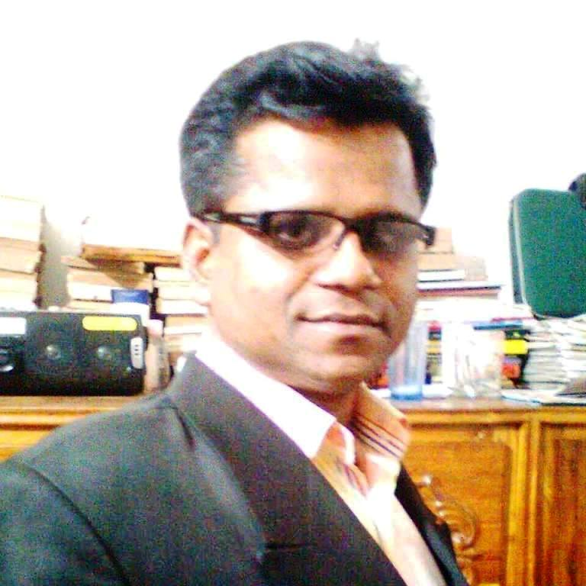
Of
Mohammad Abdullah Al Mamun
Freelance Translator

Mother Tongue : | Bengali

Bengali to English
English to Bengali

01. Areas of Concentration | : | Education, Legal Terms, Health, Medicine, Science, Fictional Terms, Technology, IT Localization, Politics, Official Documents, Environment, Vocabulary, Child Rights, Gender Issues, Business, Marketing, HRD and Government Circulation etc.

02. For correspondence please write to: hoque.intl@gmail.com, Mobile: +8801724329444

03. Proprietor | : | Hoque Translation Centre (www.hoquetranslation.com)  Affiliated to BMET under the Ministry Of Expatriate's Welfare And Overseas Of The Government Of The People's Republic Of Bangladesh at Uttara, Dhaka, Bangladesh since the early 2011 AD. It is also an enlisted member under TC Translators Café

04. Objective

To obtain jobs of Translation

05. Academic Qualification:

In the Year 2005: | Dhaka International University, Dhaka, Bangladesh.  MA in English (Master of English).
In the Year 2013 | Uttara University, Bangladesh,  LLB (Bachelor of Law)
In the Year 2004: | Uttara University, Bangladesh,  BEd. (Bachelor of Education)
In the Year 1997: | Bhawal Govt. Bodre Alam University College, Gazipur, Bangladsh.  BA (Bachelor of Arts) taking English Subjects.
In the Year 1994 | Bhawal Govt. Bodre Alam University College, Gazipur, Bangladsh.  HSC (Science), Higher Secondary School Certificate.
In the Year 1992 | Kamarjury Yusuf Ali High School, Gacha, Boardbazar, Gazipur, Bangladesh.  SSC (Schience), Secondary School Certificate.

06. Computer Proficiency

Microsoft Office, Adobe Photoshop, Internet Browsing.
Page 1 of 2

Page 2 of 2

07. Major Translation jobs, English to Bengali
⇔ Company Management
95000 words, “Coca-Cola International Beverage Private Ltd.” 350 pages of documents in Dhaka, Bangladesh.

⇔ Engineering/Construction
85000 words, “Tokyu Construction Co. Ltd.” 250 pages of documents in Dhaka, Bangladesh.

⇔ Education/Property
52000 words, “Chancellor-Consultancy” 199 pages of different papers published in Dhaka, Bangladesh.
⇔ Business Documents
3500 words, “RAK Ceramics Ltd.” 250 Pages, Dhaka, Bangladesh.

⇔ Education/Books
11000 Words, “Gourab Prokashoni” 300 Pages, in Dhaka Bangladesh.

07. Major Translation works from Bengali to English

⇔ Company Documents

50000 words, “Comtextile (H.K.) Ltd, ” 100 Page in Chittagong, Bangladesh.

⇔ Medical Documents
75000 words, “Shin Shin Japan Hospital Ltd.” 190 pages of documents in Dhaka, Bangladesh.

⇔ Construction/Developers
90000 words, “Tulip Properties Ltd.” 190 pages of documents in Dhaka, Bangladesh.

⇔ Travel Agency
99000 words, “Sun Shine International Travels & Tours” 210 Pages of documents in Dhaka, Bangladesh.

⇔ School/College
5000 words, “Rajuk Uttara Model School & College” 50 Pages of Official Documents in Dhaka, Bangladesh.

08. Personal Data
Mailing address | : | Hoque Translation Centre  Room No. 32/A-1, Rajuk Commercial Complex (3rd Floor), Plot-69, Sector-07, Uttara Model Town, Dhaka-1230, Phone : +8801724 329 444, Email : hoque.intl@gmail.com, Website : www.hoquetranslation.com

09. References:
a. TranslatorsCafe.com, 1425 Bodmin Rd. #407 Mississauga, ON L5J 3T4 Canada.

b. Professor Translation Service, Govt. Approved Translation Licence No. T.L. 41, 29, Toynbee Circular Road, Dainik Bangla Moor, (Eastern Side of NCC Bank), Motijheel, Dhaka-1000, Mobile: 01711967653, 01552414948, 01914602604,01913823940.

c. Advocate Iqbal Hossain, Supreme Court of Bangladesh, Chamber: Rajuk Complex, 2nd Floor, Room: 3, Sector-07, Uttara Model Town, Dhaka-1230, Mobile: +8801968738833.

