Gulf Localize Cloud

(India)

We Localize Your Word

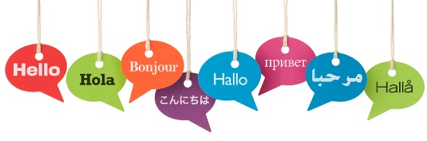

Call us : +917073261893
e-mail : info@gulflocalizecloud.com

Address:

Company Contact Information
- Gulf Localize Cloud
- Near: Mahamaya Temple Nawalgarh
- Rajasthan (India) Pin Code : 333042
- Fax: 01594 - 22997
- Contact No. +917073261893
- Website : www.gulflocalizecloud.com
- info@gulflocalizecloud.com
- Non-voice BPO (Business Process Outsourcing)
and language (s) solution.
- Mr Md. Bilal Sheikh & Mr. Mustaq Ahammed.

Company Details
- Creation of Company: November 2007 by MD. BILAL SHAIKH

Company Profile

Gulf localize Cloud bridges the language barriers for you.
Increasing the effort of your work and leading your company to more
Reachable customers.
We work just like another department of your company supporting your Core business.
Gulf Localize Cloud was founded in 2007.
We specially do transcription and translation in 50 languages and also
By a team of languages, technology, project management and business Professionals.
Our core team has over 10 years of extensive experience helping companies
Communicate and
Conduct business in any language and in any locale. We do this by providing
An array of best customer service and Globalization services including
We currently work with professionals worldwide in over 50 languages.
We have great experienced and native Translators. Who do transcription and translation

SERVICES:

• TRANSCRIPTION

Medical Transcription, General Transcription, Legal Transcription,
Business Transcription, Education Transcription, Real time Transcription
Mp3 Transcription, CD/ Video Transcription, Interview Transcription
Conference Transcription, Telephone Transcription

•TRANSLATION

Automotive Translation, Financial Translation, Mobile Apps Translation
Medical / Life science Translation, Legal Translation, Website Translation
Manufacturing Translation, Audio/video Translation
Design & Advertising Translation, IT Hardware & Software Translation,
Games & Multimedia Translation, Book Translation

•CALL CENTER

Inbound, Outbound, Sales, Lead Generation, Marketing and
E-mail Reply, Technical Support, Chat Support

• TYPESITING
• PROOFREADING & EDITING
•E-PUBLISHING
•DTP Desktop Publishhing
• Voice Over

Logo Designs, Photo Design, Photo Clipping, Photo Shop
Video Editing, Footage Editing

•Localization, Games Localization
Book Typing, Data Entry, Copywriting,
PDF/XML/HTML/JPEG Conversion, E-pub, Apps
XML/SGML Coding with DTD Design and Data Cleaning

LANGUAGES:

Middle East Languages : Arabic, Farsi, Kurdish, Dari, Pasto & Turkish

Asian Languages : Urdu, Japanese, Korean, Chinese, Malay, Nepali, Tagalog, Vietnamese, Indonesian, Thai, Burmese,

Europion Languages : Spanish, Germen, Italian, Portuguese, Russian, French, Dutch, Polish, Slovak, Greek, Swedish, Swedish, Finnish, Icelandic, Hungarian, Ukrainian & Romanian

Indian Languages : Hindi, Bengali, Tamil, Telugu, Kannada, Malayalam &
Punjabi

Language pairs for our target group
Our language pairs are aimed at our main target group which is located in the European countries of all, and around the world. We translate from and into Arabic, French, Hindi, English and German and other languages

Our translation office offers qualitative translations in the following language pairs:

Source language | Target language
Arabic | French, German, Greek, Italic, Farsi,  English, Spanish, Japanese, Hindi, Urdu, Russian  Turkish and Kurdish
French/German | Dutch, Arabic, Spanish, Portuguese, Hindi, Urdu,  English, German,
English/ Hindi | Dutch, Arabic, Urdu, Hindi, Russian, Spanish,  Japanese, Korean, Greek, Farsi, German, Chinese,  Turkish, Bengali, Punjabi, Tamil, Telgu, Portuguese,  Chinese, Italic, Malay, Swedish, Finish, Romanian,  Burmese, Thai, Hungarian, Indonesian, Nepali,  Guajarati, Persian, Dutch, Danish, Sanskrit, Malayalam,  Kannada, Vietnamese, Romanian, Polish, Kurdish, Slovak, Ukraine, French, Hebrew, Dari, Pasto, and African Languages
- German to Arabic  - Turkish to Chinese  - Spanish to Arabic  - German to Chinese  - French to Arabic  - Italic to Arabic  - Arabic to Hindi  - Greek to Arabic  - Spanish to Greek  - Chinese to French  - Arabic to Urdu  - Japanese to German | Arabic to German  Chinese to Turkish  Arabic to Spanish  Chinese to German  Arabic to French  Arabic to Italic  Hindi to Arabic  Arabic to Greek  Greek to Spanish  French to Chinese  Urdu to Arabic  German to Japanese

Following industries:.
- Health, Education, Tourism, General, Agricultural,
- Technologies, Hospitality, Fashion, textile, Science
- Legal, Retail, Medical, Business, Automobile, Sports
- Food, Insurance/Bank, Manufacturing, Arts
- Energy, Real Estate, Games, Oil & gas and other Industries.

Technical:

We provide 99.99% quality with high range of accuracy.
We are committed to the highest standards and quality
Excellence.
We do work almost in all languages.
We go above and beyond for our clients; we treat them like
They are a part of our family.
We are available 24/7 around the clock

Guaranteed Accurate, Efficient and Timely Services
Responsible and Reliable Team; With Perfect - We Deliver!

Our Mission:

Gulf Localize Cloud is aiming to be the best in the Language (s) and Non-voice Industry by giving them the best service and work force. Not just here in located office but beyond the thinking, and we finished our work (target) in time with 99.99% quality, our employees have every time work pressure on the floor.

Our Vision:

VISION: Gulf Localize Cloud as a Successful Company and will continue to rise in language industry, READY TO BE YOUR BRIDGE TO SUCCESS ! Our Long term goal is staying with the company who believed in us.

Absolutely language (s) solution

بلغة تماما (ق) حل
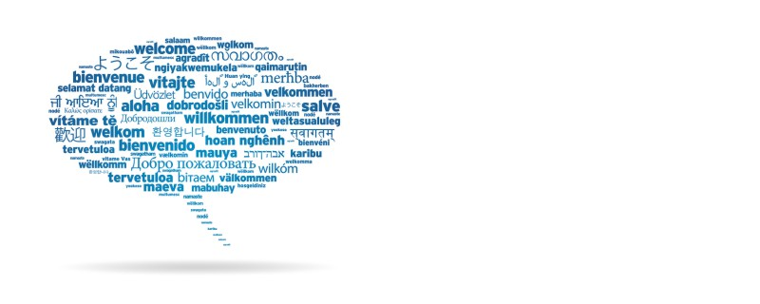

Gulf Localize Cloud (India)

