**Testimonials:**

***Vadim Malchikov, Clear,.Super Power, Power FSM***

«Overall I highly recommend Vladimir. He is highly skilled, routinely exchanges in abundance, very ethical, possess great integrity, extraordinarily willing & caring, and discreet & service oriented with celebrities and others.

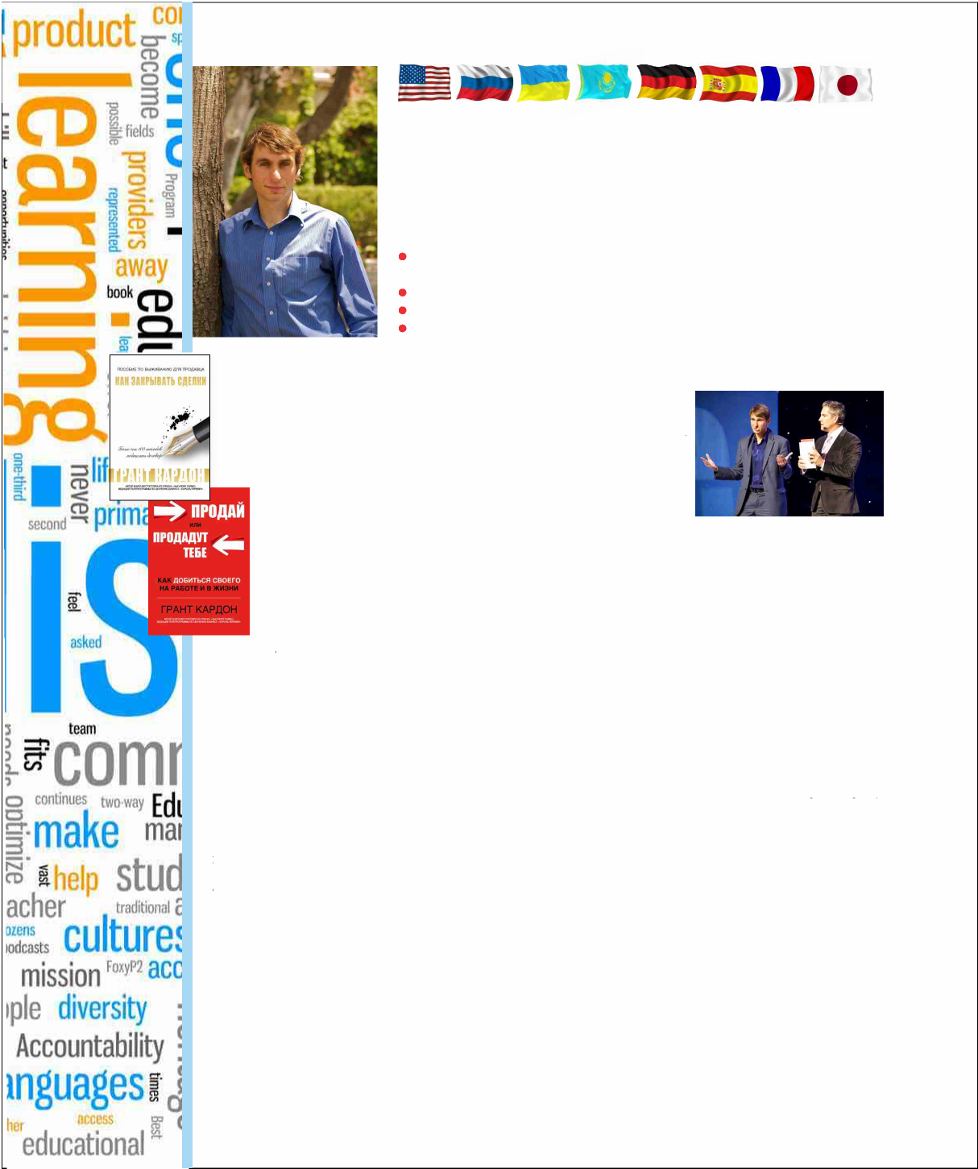

**Vladimir Reznikov**

Professional translator and interpreter, who’s been especially invited to fly across the planet and work in Dubai, as well as work at confidential film negotiations in LA. Translator and editor of Grant Cardone’s books.

**Services:**

**Translation and interpretint (simultaneous, consecutive) – into Russian, English, Spanish and German (others possible);**

**Escort-interpreting in the US for business meetings or as a guide**

**Conference interpreting anywhere in the world;**

**Language classes**

I really appreciate Vlad’s recent translation services at the Russian convention I recently spoke at. Vlad was able to capture my concepts and ideas, including all the American slang and idioms, and make them fully duplicatable in the Russian language. I could see by the audience’s response that Vlad had totally delivered my communication. I felt like I was in full rapport with Vladimir as my facilitator. Thank you for the care and attention

to excellence!

***Grant Cardone***

*Благодаря Владимиру эти книги  
Гранта Кардона в отличном переводе  
теперь можно читать по-русски!*

***Dror Soref***

*(Has worked with John Travolta, Paz Vega, Chloe Moriotz, Peter O‘Toole and others; has also helped L. Ron Hubbard found Golden Era Productions).*

«Vladimir is a professional! Our company has worked with him for over five years. All the projects have been done precisely on time and were high-quality. He thinks equally well in English and Russian, and his speech and the written word are distinguished by literacy. We highly recommend him.”

***Alla Musatova****, OT8, Super Ppower*

*ATManagement group co-owner*

«I was very happy with Vladimir’s translations. I can speak English myself, but I needed literary English, without Russian patterns of figures of speech. It had to sound native and fluent. When English speakers read read the text, they would never even get the idea that this was a translation. Details are important in the business world. Vladimir knows the intricacies of the language, as well as American culture and traditions, and he practices constantly in his field .»

***Ludmila Peacock***

*WISE consultant*

**In the works now:** a new book by Grant Cardone, as well as a book by Vadim Malchikov and Andrey Sizov

"My respect and admiration to Vladimir. From a professional to a professional. Wishing you happiness and your goals come true".

[**vladimirarc@yahoo.com**](mailto:vladimirarc@yahoo.com) **US phone: +1 (612) 978-07-71  
5kуре: rimidalvarc**