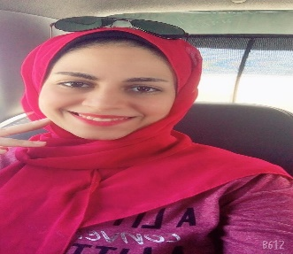  Objective  I’m a clinical pharmacist, toxicologist, quality control manager, and medical translator.  Skills  - Self and continuous learning.  - Good dealing with office programs.  - Excellent English.  - Good team worker.  - Best time and issues management.  - Flexibility with all types of work.  - Deal with translation programs such as Trados and meme q.  - Critical thinking and a strong ability to solve problems. | Zainab  Elgazzar  freelance medical translator  Experience  2014–2017  Community pharmacist • Abo alkheir pharmacy.  2019–2022  Hospital pharmacist • clinical • Kafr saad central hospital.  2021  Quality management specialist at Kafr saad central hospital.  2022  Medical translator • dew treats academy.  Education  Faculty of Pharmacy, Mansoura University, Egypt.  - Bachelor of pharmaceutical sciences (2017).  - Diploma in clinical pharmacy (2018).  - Diploma in toxicological, forensic, and chemical analysis (2021).  Al-Sadat academy for business management  - Diploma in quality control and hospital management (2019-2021).  Dew treats academy  - Medical translation course (2022).

