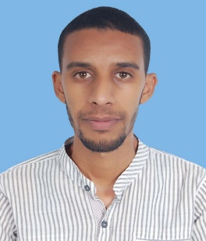
Name Soufiane AMZILE
Address № 123, alley Meknes, Oued Dahab, Ourazazate
Telephone 0641934041
E-mail Soufian99@gmail.com
Date of birth 22 July1990
Nationality Moroccan
Sex Male
Civil status Single

- EDUCATION/QUALIFICATIONS

2014: (Licence professionnelle) Professional degree in multilingual communication at the King Fahd Advanced School of Translation in Tangier.
- Research project fulfillment of the requirements for Professional degree: «THE LANGUAGE USED BY MOROCCANS ON VARIOUS TYPES OF WEBSITES».
2014: Training term in the provincial Delegation of tourism in Ourazazate from 5 to 30 Mai 2014
2013: (BA) licence in English Studies, Linguistics major at Ibno Zohr University /Agadir.
-Research project fulfillment of the requirements for Bachelor of Arts
«INTERNET LINGUISTICS: THE EFFECTS OF NEW TECHNOLOGY ON ENGLISH LANGUAGE, LEARNERS AND COMMUNICATION».

2012: (BEd) bachelor of Education in Ibn Zohr University/Agadir

2012: Training in Micro teaching at EVE Centre /Agadir
2010: Baccalaureate of Arts and Humanities.

- WORK EXPERIENCE/ACTIVITIES

2014: Journalist/reporter at the Arab Center Press Media
2009: Secretary of the parents and students association at the high school Elworoud, kelaat Mgouna
-Reception service
-inscription assistance
2008: Employer at the patisserie
2008: Candidate at the leadership camp (GGLOW) organized by the American Organization Peace Corp
2006: Candidate at the El-jadida linguistic camp organized by the American Organization Peace Corp

- COMPUTER AND LANGUAGE SKILLS
Arabic: native language, Tamazight: Good, English: fluent, French: intermediate
Computer literate: Windows applications; Translation tools;
- ACTIVITIES/ INTERESTS
Ping Pong, Soccer, Reading, Translation.

